Task Sheet: “Survival in Sarajevo” by Centropa
- What message do people that were involved in Benevolencija transmit?
……………………………………………………………………………………………………………………………………………………………………………………………………………………………………………………………………………………………………………………………………………………………………………………………………………………………………………………………………………………………………………………………………………………

- Did this film affect your image of relationships among people of different religious background and if it did, in which way?
……………………………………………………………………………………………………………………………………………………………………………………………………………………………………………………………………………………………………………………………………………………………………………………………………………………………………………………………………………………………………………………………………………………

- How do you think you would react if you were there too?
…………………………………………………………………………………………………………………………………………………………………………………………………………………………………………………………………………………………………………………………………………………………………………………………………………………………………………………………………………………………………..……………………………………………...

- Three years with bomb attacks, without water-electricity-food, without transportation, schools or work. Do you believe that this experience changes a person? Explain.
…………………………………………………………………………………………………………………………………………………………………………………………………………………………………………………………………………………………………………………………………………………………………………………………………………………………………………………………………………………………………………………………………………………………………………………………………………………………………………………………………………………………
……………………………………………………………………………………………………………………………………………………………………..……………………………………………………………………..……………………………………………………………………………………………………………………………………………………………….
- Have you ever heard of facilitating the escape of underage people in order for them to avoid a sweeping social crisis? Give examples.
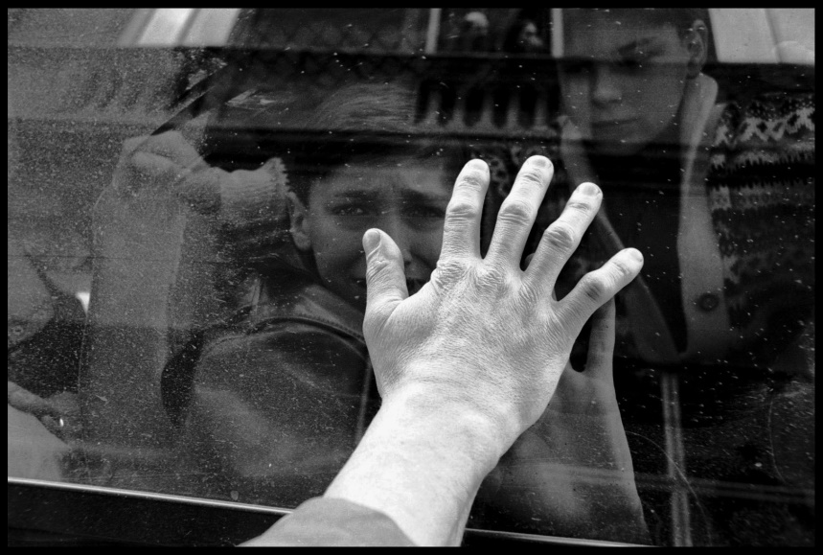
……………………………………………………………………………………………………………………………………………………………………………………………………………………………………………………………………………………………………………………………………………………………………………………………………………………………………………………………………………………………………………………………………………………………………………………………………………………………………………………………………………………………………………………………………………………………………………………..………………………………………………………………………………………………………………………………………………………………………………………………………………………………………………………………………………………………………………………………………………………………………………………………..

- What may Denis be thinking of the moment the bus starts?
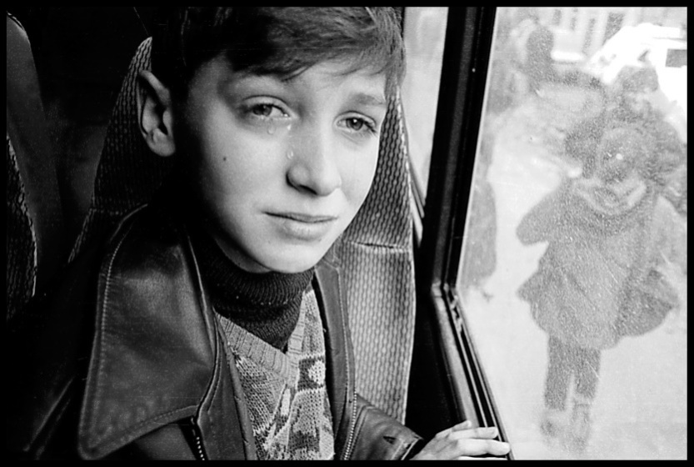
………………………………………………………………………………………………………………………………………………………………………………………………………………………………………………………………………………………………………………………………………..……………………………………………………………………………………………………………………………………………..…………………………………………………………………………………………………………………………………………………………………………………………………………………………………………………………………………………………………………………………………………………………………………………………………….….
………………………………………………………………………………………………………………………………………………………………………………………..…………………………………………………………………………….…
- Nowadays Denis works with Centropa. If you were him, how would you continue your life?
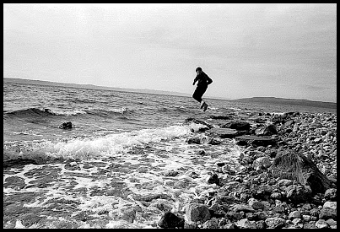
…………………………………………………………………………………………………………………………………………………………………………………………………………………………………………………………………………………………………………………………………………………………………………………………………………………………………………………………………………………………………………………..…………………………………………………………………………………………………………………………………………………………..………………..…………………………………………………………..…………………………………………………………………………………………………………………………………..

- Use the three pictures above and write a story which you will present using photostory3
………………………………………………………………………………………………………………………………………………………………………………………………………………………………………………………………………………………………………………………………………………………………………………………………………………………………………………………………………………………………………………………………………………………………………………………………………………………………………………………………………………………………………………………………………………………………………………………………………………………………………………………………………………………………………………………………………………………………………………………………………………………………………………………………………………………………………………………………………………………………………………………………………………………………………………………………………………………………………………………………………………………………………………………………………………………………………………………………………………………………………………………………………………………………………………………………………………………………………………………………………………………………………………………………………………………………………………………………………………………………………………………………………………………………………………………………….………

