Synagoge Turnergasse
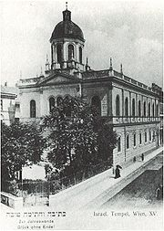 The synagogue in the Turnergasse, around 1900

The synagogue in the Turnergasse 22 in the 15th district in Vienna was built between 1871 and 1872. It was erected as a detached building and used by the Jewish community from 1871 until 1938.
Architect Professor Carl König planed it in the Renaissance style and there were 496 seats for men and 333 seats for women. In 1923 it was completely renovated from the inside as well as from the outside. The entire amount of 160 million Kronen was donated by the members of the Jewish community. As the oratory was too small also an extension was built at the same time.
In the early morning of November 10th, 1938 in the Night of the Broken Glass (Kristallnacht 9th/10 November 1938) the synagogue was destroyed due to fire raising. Only one of the 93 Synagogues in Vienna survived those days of riots and destruction – the Stadttempel in the first district, which was damaged but renovated after the war and reopened.
In May 1940 Leopold Hölzl, a freight carrier, “bought” (Aryanised) the property were the synagogue Turnergasse stood for only 38.500 Reichsmark.
1947 a compromise settlement was reached and the Hölzl Family built a garage and a fuel station on the ground of the former synagogue. In 1973 the grounds were sold to the municipality of Vienna.
Between 1976 and 1979 council flats were built and the area where the synagogue used to stand was left empty, a fenced bit of grassland. Finally in 1988 a commemorative plaque was installed quietly in a hidden corner of the council building.

