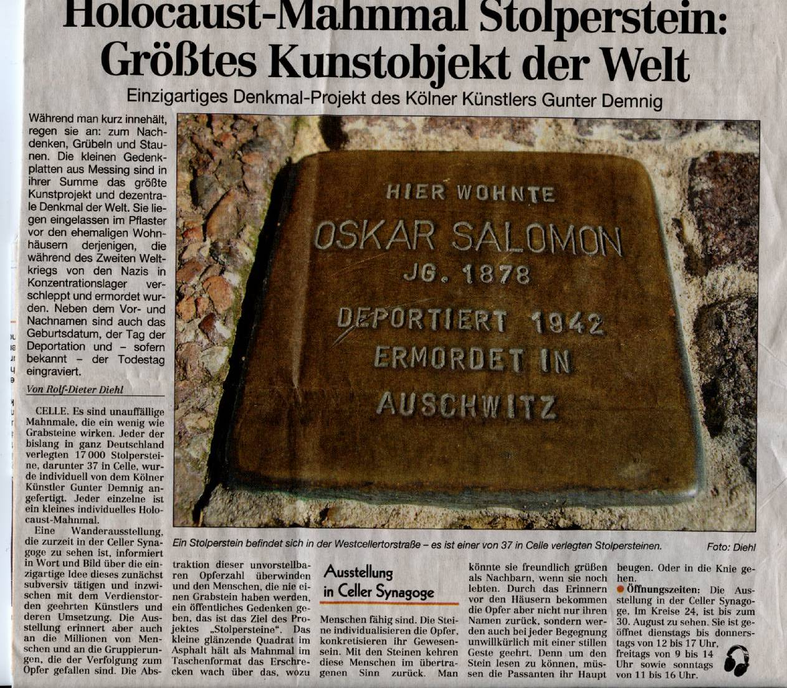
With friendly allowance of the Cellesche Zeitung (2009-11th July)

Inscriptions of the plate: “Here lived Oskar Salomon, born 1878, deported 1942, killed at Ausschwitz”

