Renata Laqueur guest at Heinrich-Pröve-Realschule
“How we kept alive? We didn’t begrudge them our death.”
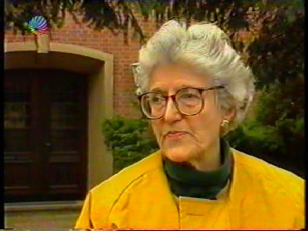
Respectful silence fills the classroom of the Heinrich-Pröve-Realschule at Winsen. Suddenly there is a question of a student: “What are you feeling today, having come back to Bergen-Belsen but as a free person?” Renata Laqueur, 77 years old and survivor of the KZ Bergen-Belsen speaks about her hopes and fears as a prisoner of the camp.
“In some way this book is reflecting the efforts of an eyewitness to escape reality by writing, and it leaves the reader to his imagination to get an idea of the reality.” Starting with this excerpt of her diary Mrs. Laqueur abducts the students into a time which she, as she said, hasn’t forgotten but suppressed.
It all started on February 18th, 1943 when Renata Laqueur (Dutch) was arrested at Amsterdam for the first time. After the enforced deportation to various transit camps she and her husband Paul were transported to Bergen-Belsen on March 22nd, 1944. During this time - from March 1944 to April 1945 – she began writing her diary.

Wednesday, March 22nd, 1944:
“This evening the low-flying English bombers’ motors droned me to sleep. What’s their target, Hamburg, Berlin ...?”

“How did you keep alive in such a hopeless situation?” a student wanted to know. “We didn’t begrudge them our death, their triumph in killing you. You cling to the past, to hope. Furthermore writing the diary gave me new power. It was a kind of a therapy, a “writing out”, Mrs.Laqueur remembered.
She didn’t feel any hatred: “My God, hate is of no use. I’m simply lucky, that I’m living.”
With friendly allowance © Cellesche Zeitung (May 7th , 1997)

