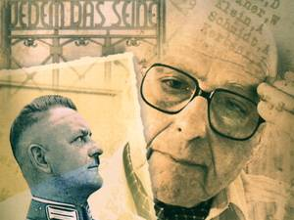
John Weiner
John Weiner (who died in November 2006), was a Hungarian who emigranted to Australia nearly 50 years ago. He lost his mother in Auschwitz Concentration Camp and his father in Buchenwald. He survived on the march from Buchenwald to Dachau and hid with 12 other detainees in Ergoldsbach. The SS detected them, and handed them over to the village policeman Maurer to be shot. But he hid them from the SS on the estate of Anna Gnadl, his wife. The next day the Americans liberated the thirteen survivors.
