European History Map

Traveling they say, broadens the mind. And when we travel to Europe we wonder:

How did mosques and Ottoman built bridges like this get into southeast Europe—like here in Bosnia. | 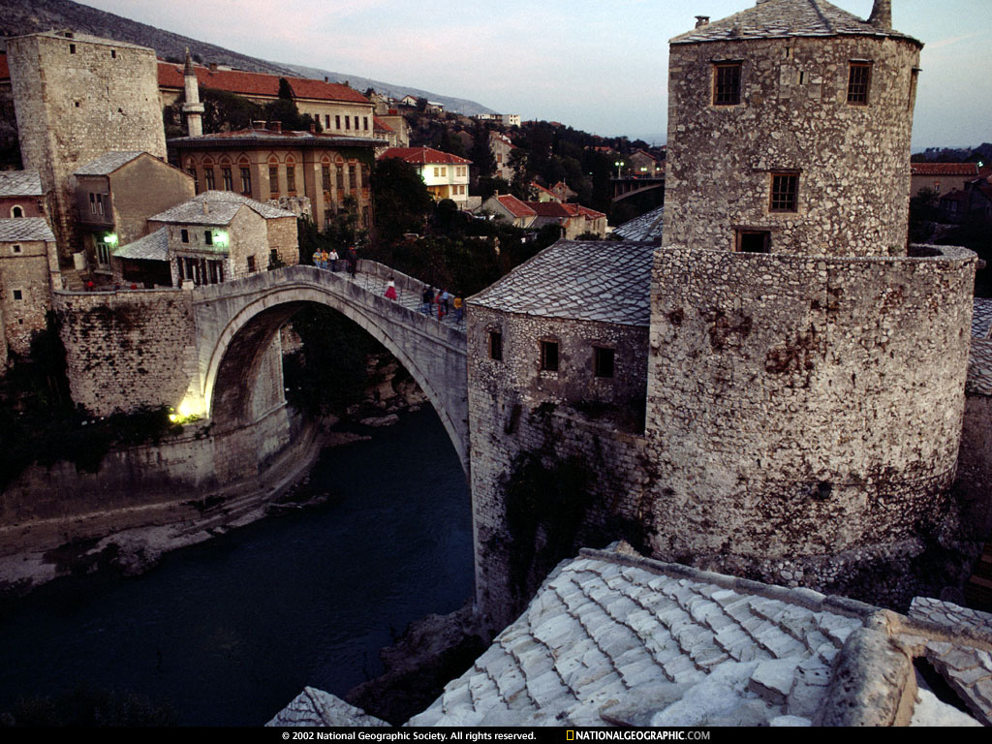
And while we certainly think that Prague is beautiful, many Czechs will tell you that all this glorious baroque architecture was built by the Austrians, not the Czechs. | 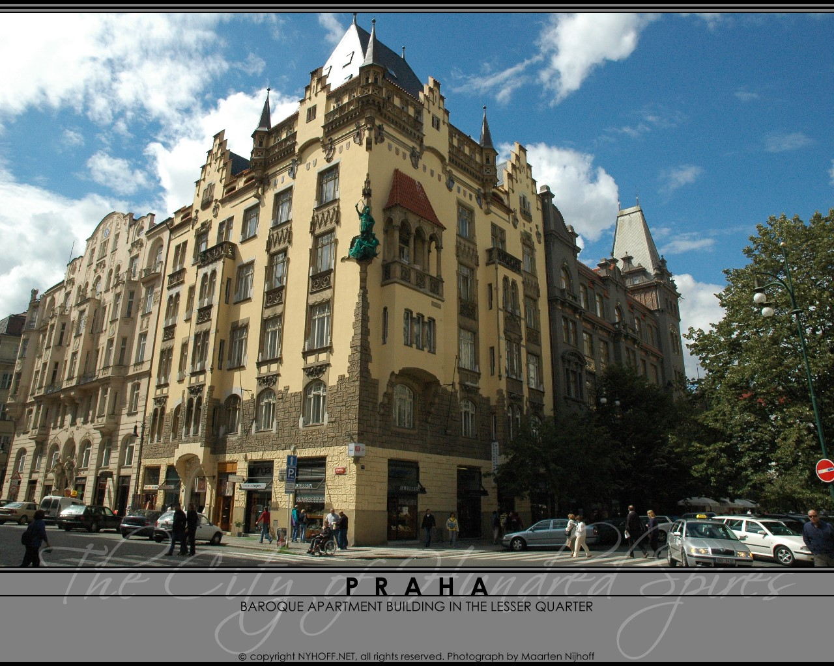
And when you visit Warsaw, Poles will tell you that hideous buildings like this are soviets, not theirs
So this short trip through Europe’s maps is meant to explain just a little about how borders moved, and how cultures moved with them
This is how Europe looked after the Treaty of Vienna in 1815.  There were three big empires—the Austrian Empire, ruled by the Habsburgs; the Ottoman, or Turkish empire, ruled by its sultans, and the Russian empire, ruled by the Romanovs.  Germany— there wasn’t a country called Germany yet -- Prussia was the dominant state.  Poland? From the 1790s until 1918 there was no country called Poland—it had been carved up by the Russians, the Prussians and the Austrians. | 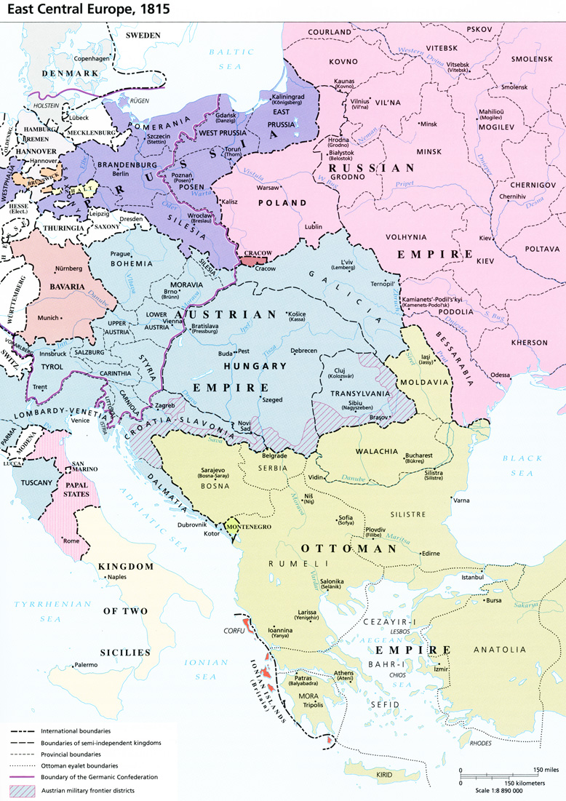
By the beginning of the 20th century, the Ottoman Empire had been greatly reduced and these four countries came into existence: Romania, Bulgaria, Serbia,  Montenegro and since 1867 the weakened Austrian Empire had become the Austro-Hungarian Empire.  Beginning in 1871 Germany was united under Chancellor Von Bismarck and ruled by Kaiser Willelm I and his successors. | 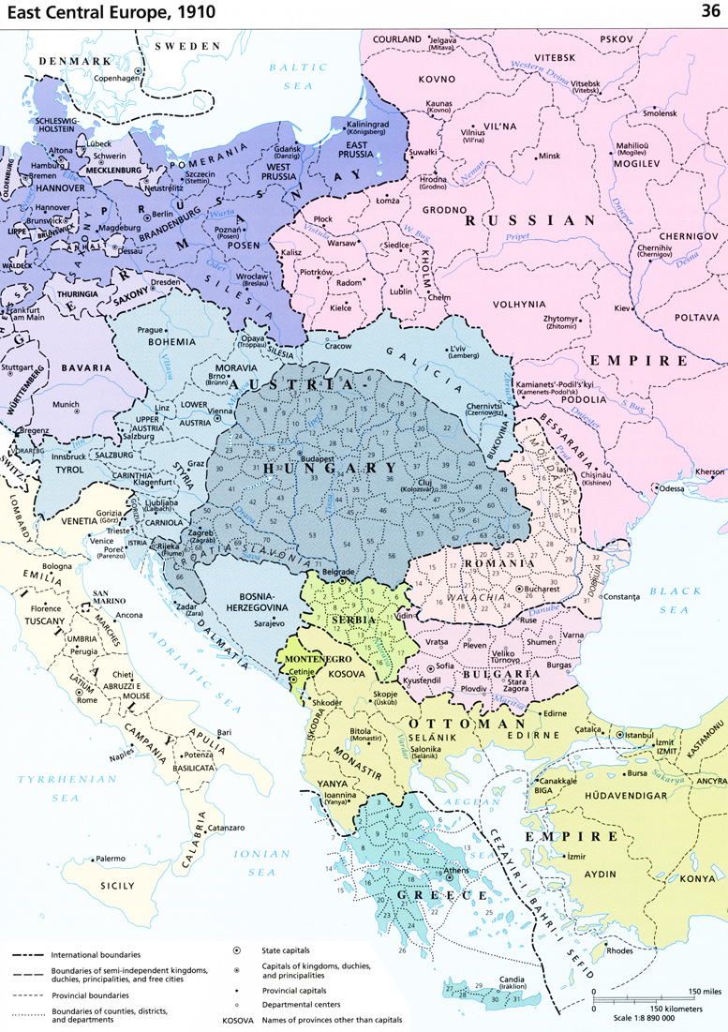
Here’s the Austrian archduke Franz Ferdinand in Sarajevo in June 1914—A few minutes after this picture was taken, he and his wife were assassinated. | 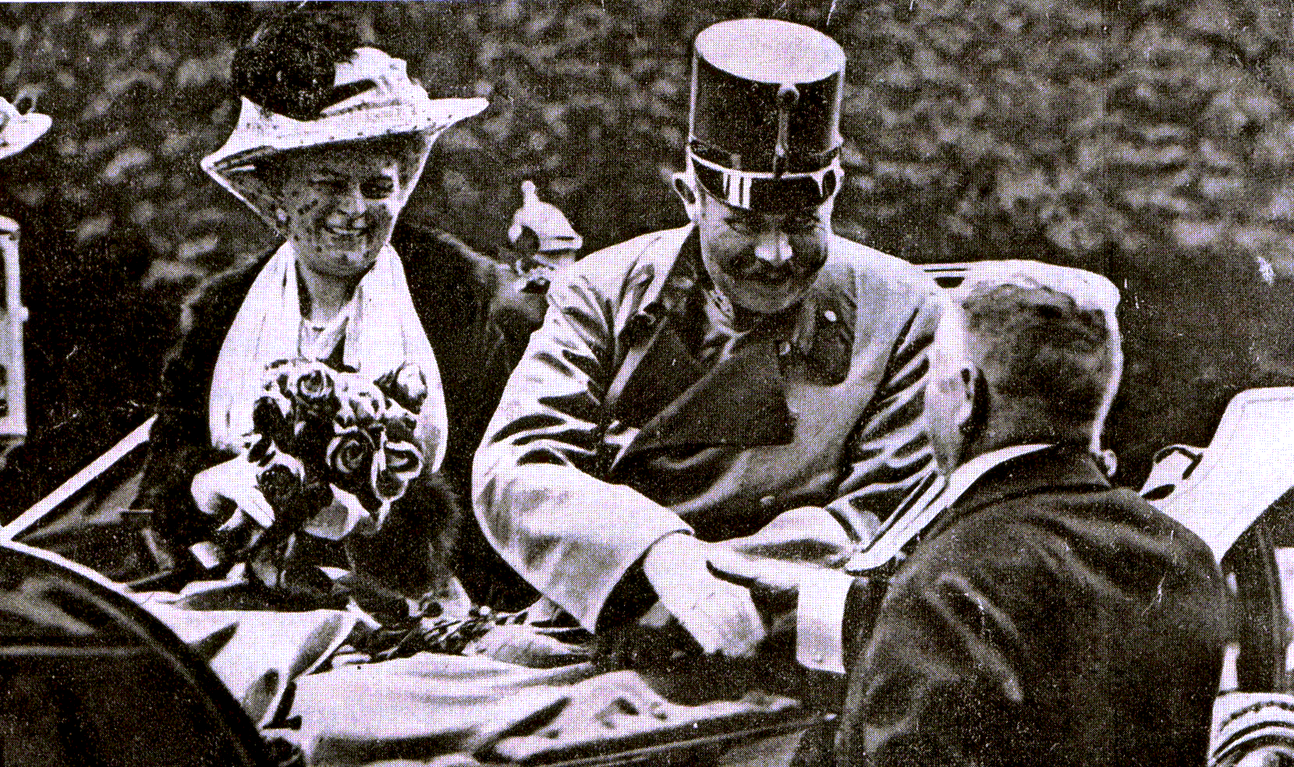
This was the event that touched off the First World War. Some called it the Great War. Millions died. And when the smoke cleared in 1918, all the great empires of Europe had vanished.
After the Treaty of Versailles in 1919, the victorious Allies had redrawn the map of Central Europe completely.
Russia became the Soviet Union —led first by Lenin, then Stalin.
Germany became democracy but the Weimar Republic was hated by the country’s extreme right as well as the extreme left.  Germany’s first democracy was born in a time of economic upheaval, social instability and political assinations. | 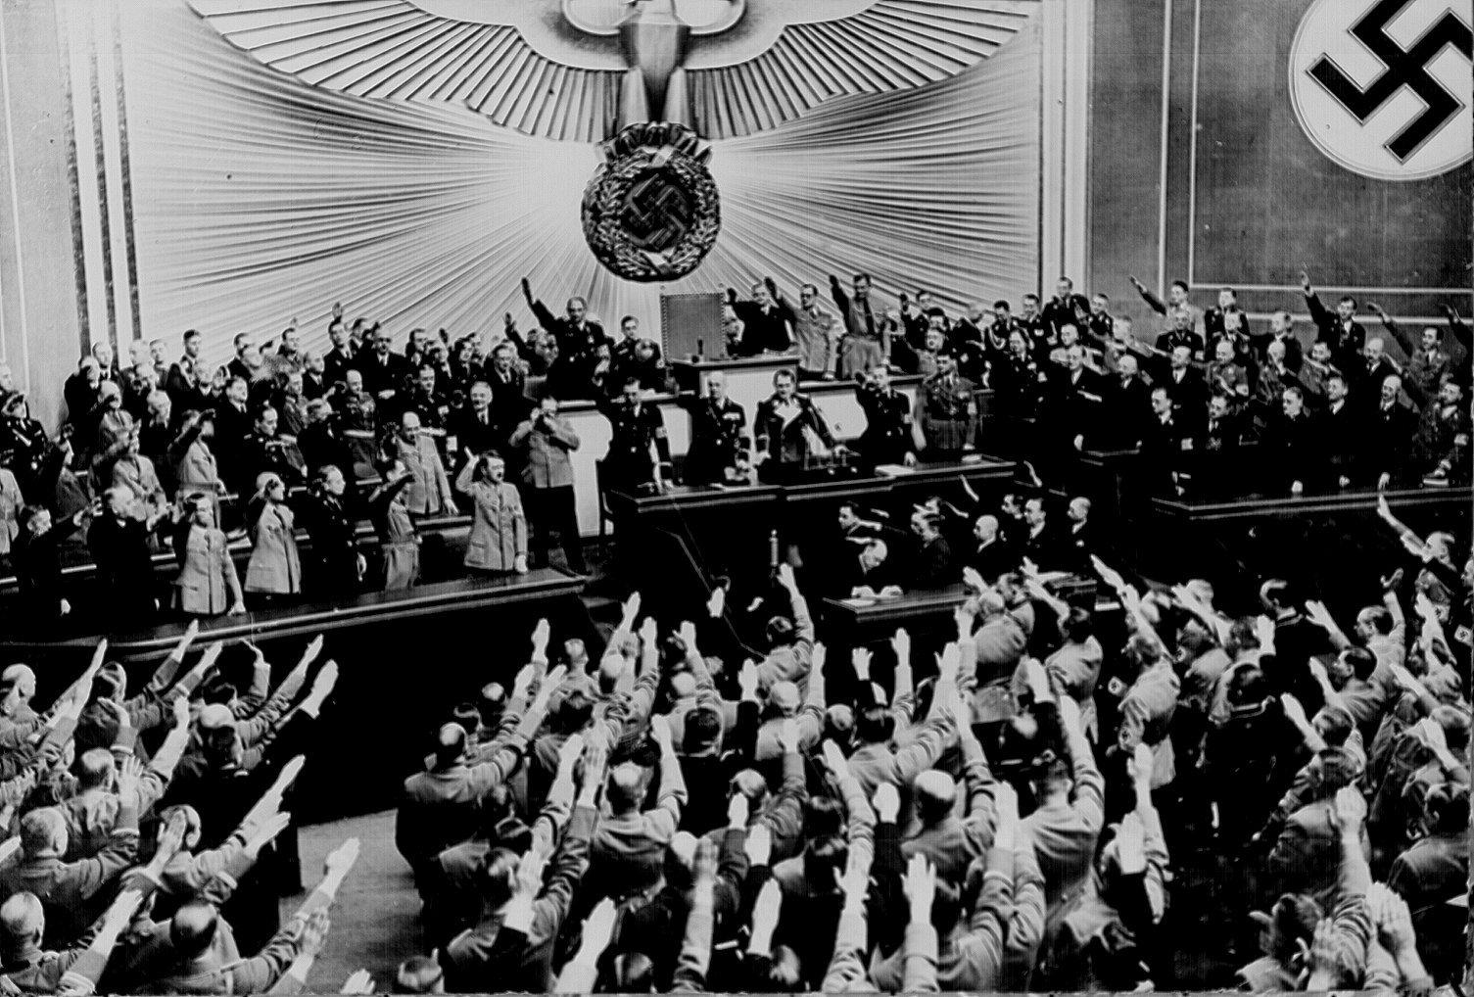
Poland was reborn for the first time since the 1790s.
A new country, Czechoslovakia, was carved out of the Austro-Hungarian Empire and proved to be the only stable democracy in Central Europe.
Both Austria and Hungary were dismembered and greatly reduced in size. Romania, which had been on the Allied side in the First World War, was greatly enlarged.

And in the Western Balkans a new country was formed, Yugoslavia.
It seemed that no one in Europe was fully satisfied with the Treaty of Versailles. Many said that it would be only a matter of time before war again.

The Great Depression began in America in 1929 and quickly made its way to Europe.

In Germany, the extreme right-wing party, the Nationalsocialists under Adolf Hitler, took power in 1933.
Austria became a dictatorship in the same year as Germany and Italy preceded them both with Mussolini.
Adolf Hitler was bent on changing the map of Europe his way.
He marched into Austria in 1938 and then demanded a portion of Czechoslovakia. The British and the French governments agreed to give it to him in the Treaty of Munich in 1938.
The British prime-minister Neville Chamberlain said we would have ‘peace in our time’.
But then German forces invaded Poland in 1939, setting of the Second World War, a war that killed tens of millions of people.
Cities were destroyed and the vast majority of Europe’s Jewish population slaughtered.
While American troops liberated Western Europe in 1944, in 1945 the Soviet Union liberated Romania, Bulgaria, Hungary, Poland, the Baltics, most of Czechoslovakia and a part of Germany.
But wherever the Red Army went, they left communism behind.
In 1946 Winston Churchill said an iron curtain had been drawn across Europe, dividing East and West.
By 1948 a new war, the Cold War, had begun.
The symbol of the Cold War was here, in Berlin. An ugly wall was built in 1961 between communist East-Berlin and West-Berlin.
West-Berlin was then called the island in the Red Sea.
But in 1989 Communism collapsed in Central Europe,
And two years later in 1991-- it collapsed in the Soviet Union as well.
The Czechs and the Slovaks went their peaceful ways in 1993.
Yugoslavia descended into a series of wars which lasted from 1991 to 1999.
As you’ve seen in this short film, Europe’s maps have never really stopped changing and Europe’s history as we see is still being written

