The family and the Reinhold enterprise

The world enterprise Reinhold & Co was established in Celle. And some years later, it had branch offices all around the world. Sartorius Reinhold was born in Oberlahnstein on 26th March 1853. His parents were Seligman Reinhold and his wife Josephine. Otto Reinhold was born in Ehrenbreitstein on 14th March 1855. About five years later, the father took over the first military deliveries. The enterprise experienced an enormous
economical upswing during the Franco – Russian War of 1870 – 71. Being Sartorius took over the delivery by himself. His father suddenly died and his widow Josephine took over the management. They moved to Cologne and the two sons started a career in banking in Berlin and Cologne. In 1873, Otto Reinhold moved back to Celle and took over the work on military business. In 1877, Sartorius moved to Hanover, two years later he moved to Celle. The family bought a small house near the new Heath Barracks. They cooked the military meals in the washing – room. Otto Reinhold extracted oil in the Heath. In 1880, they bought their/the first gravel pit. On 7th February 1886, Otto married Elise in Hanover Later on, Sartorius married Berta Levy. In 1892, the exhibition in Leipzig was a great success. The same year, Bomann Museum of Celle was founded by Sartorius. They family donated a lot of money to poor people and built a house for the children of their workers. Twenty children lived there in big rooms with veranda and a big garden with twenty small gardens. This house was called the Reinhold’sches Holiday Home. After the First World War, the Hanoverian City Council got this home. In 1893, Sartorius built the Castle Barracles in Celle. One year later, the two brothers built a new warehouse for which they got many awards. In 1914, Otto lest his oldest son Paul. On the Stöckner Cemetery, there is a gravestone put under a preservation order. Sartorius died in 1915. The Holiday Home was closed down in 1927. The Castle Barracks burned down in 1936. Sartorius’ widow died in 1942. Nowadays the Reinhold family enterprise isn’t known anymore.

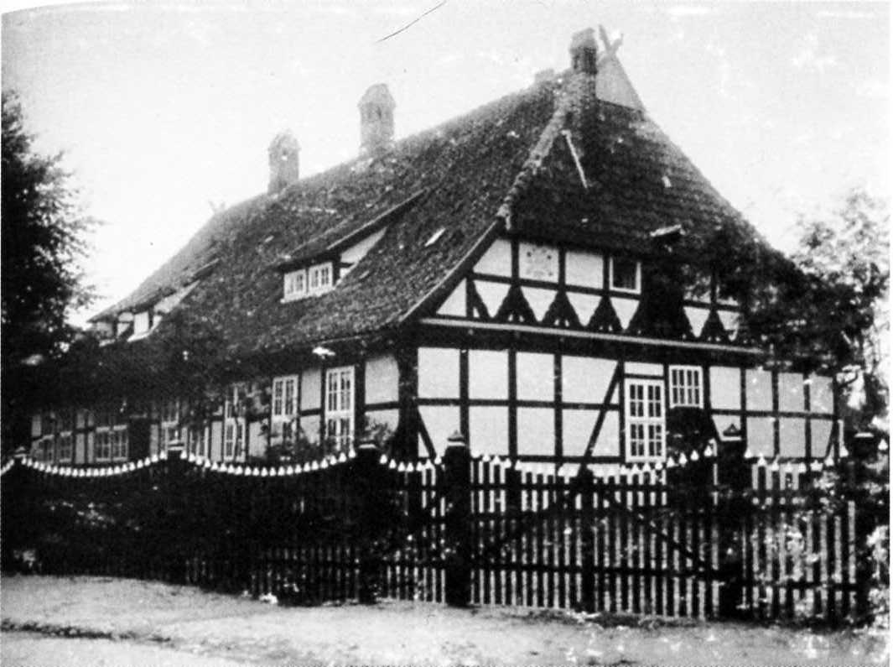

Manson of the family Reinhold at Winsen, Aller

