Robert Meyer

The son of Isidor Meyer and merchant in the third generation.
Robert Meyer was born 10th October 1874 in Celle. In 1899 he married and had 2 children. 1913 he took over the wholesale warehouse Meyer& Co from his father. For the expansion of the warehouse a new building had been constructed at the “Großer Plan” 2-3. Constructor was the same as at the Bomann-Museum in Celle. Because of the great concurrence of the new build warehouse of Rudolph Karstadt just on the other side of the street, Robert Meyer closed his business, rented the house to Karstadt and got manager in the Karstadt furniture store, his son Adolf got a job there, too. 1933 he lost his job, because Karstadt dismissed all Jewish employees because of the pressure of the NSDAP. Therefore he went from Celle to Bremerhaven, Berlin and Hamburg. After the pogrom night 1938 he was forced to sell his house at the “Großer Plan” to the city of Celle. But the city didn’t sign the contracts and so Robert Meyer didn’t get the money to follow his children, who had already immigrated to the USA. After two years the city lost the interests in the building and in 1941 Meyer sold the house to a German merchant. But he didn’t get the money, because the Financial department of Celle didn’t give the approval and so the last possibility to immigrate went by. 1943 Robert Meyer was brought to the concentration camp in Auschwitz. There he died on 16th March 1943.
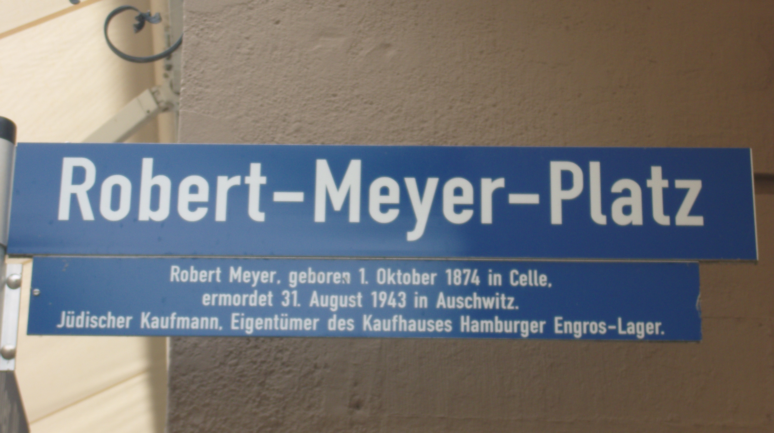
Today the place in front of the warehouse is named Robert-Meyer-Place.

