Jewish Life in Berlin
The Jewish community of Berlin offers many services to all Jews in the city, more than 11.000 People are members of the community, which makes it the largest one in Germany.
The Jewish community manages many institutions, which help Jews to develop their Jewish identity and non-Jews to find out more about the culture, lifestyle and traditions.
One of those is for example the Jewish Museum in the Lindenstrasse, Kreuzberg, which for example had an exhibition called “Weihnuka”, which compared Chanukah and Christmas.
Many Jewish kids and also non-Jewish children visit the Jewish elementary school, the Jewish Kinder garden or the Jewish high school, where they learn Hebrew and Jewish religion, which they can’t in other schools. Also there is a Jewish youth centre, where the kids play, learn about Judaism and celebrate the holidays together. As a special highlight, the youth centre organizes so called “Machanot”, summer camps, to Italy, Germany and Israel, every summer and winter.
Berlin has a Jewish sports club called “Makkabi Berlin”, which offers soccer, basketball, swimming, table tennis and many more.
The religious diversity in Berlin is high, there are orthodox, egalitarian and liberal Jews, just to name some, consequently Berlin has six synagogues. The most famous one is probably the one on the Oranienburgerstr, which is worldwide known as a very beautiful one with a golden cupola.
Other remarkable synagogues are the liberal synagogue (Pestalozzistrasse) and the orthodox synagogue (Joachimstalerstrasse).
Also Berlin houses several Jewish cemeteries, such as the cemetery Heerstrasse or the cemetery Weißensee.

Here are some pictures from the youth centre “Olam”:

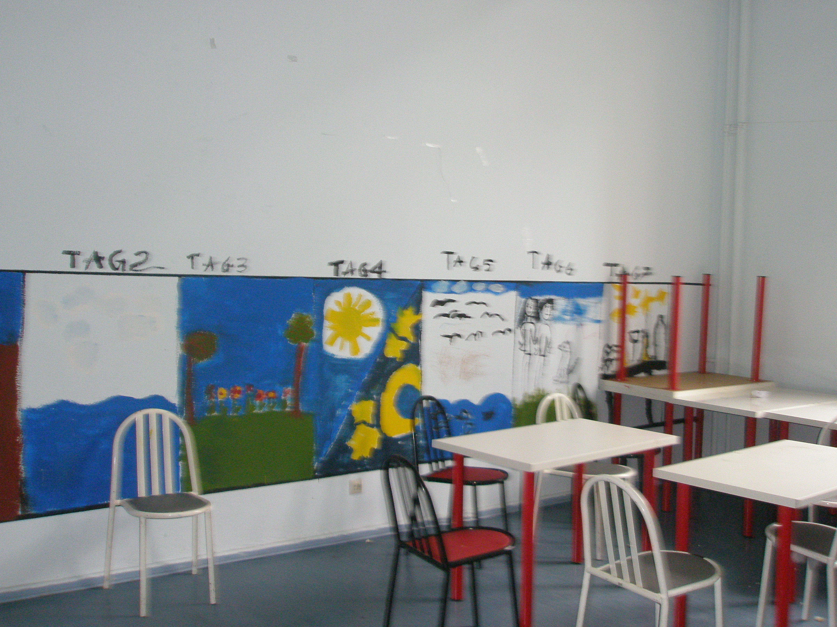

A “Kwutza- room”. (On the wall is a picture of the creation of earth)

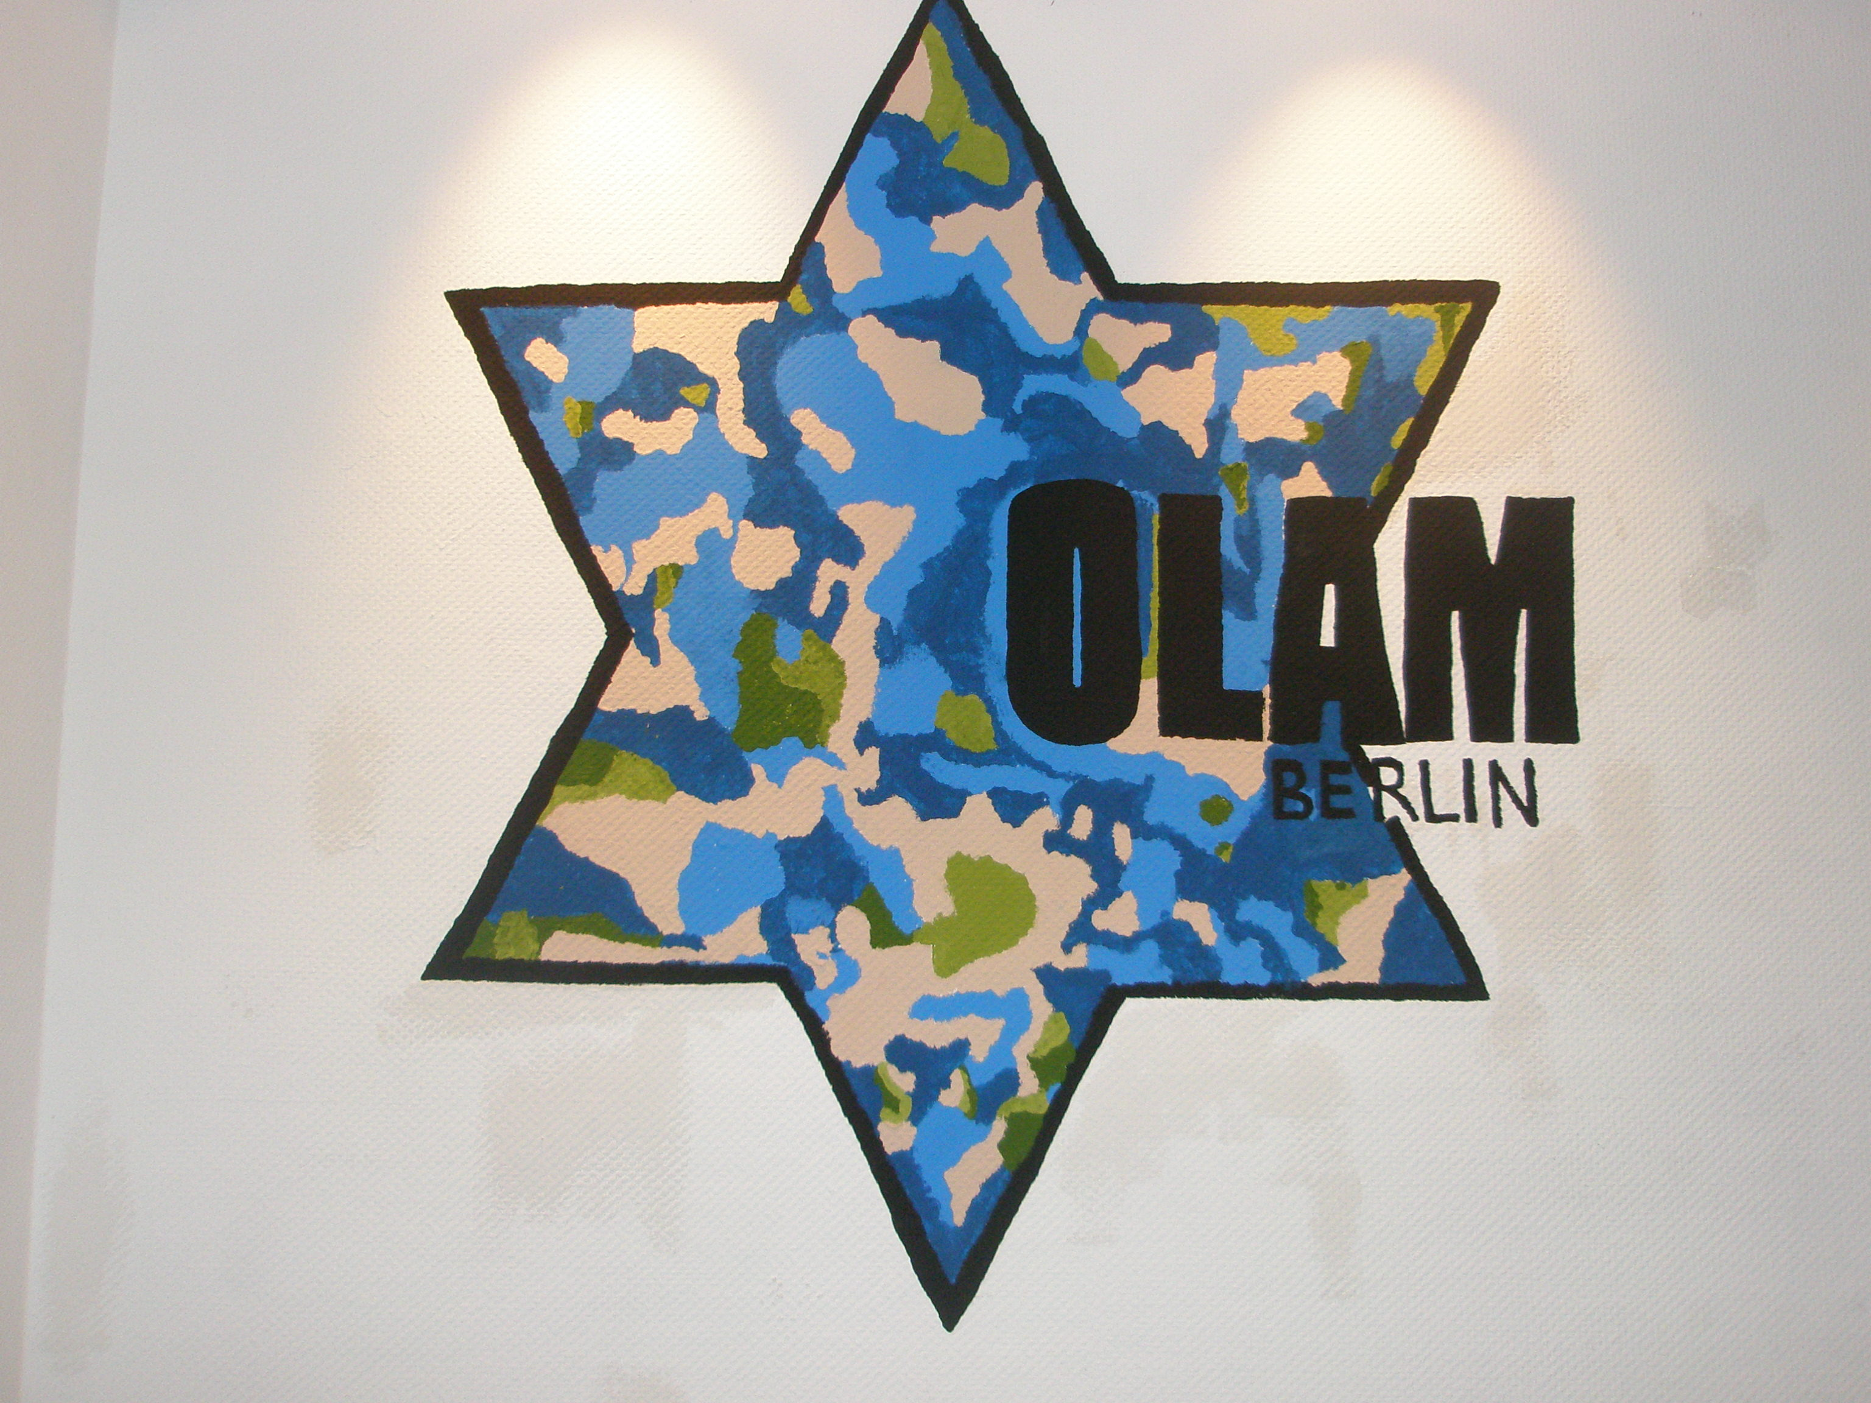

The Symbol of “Olam”

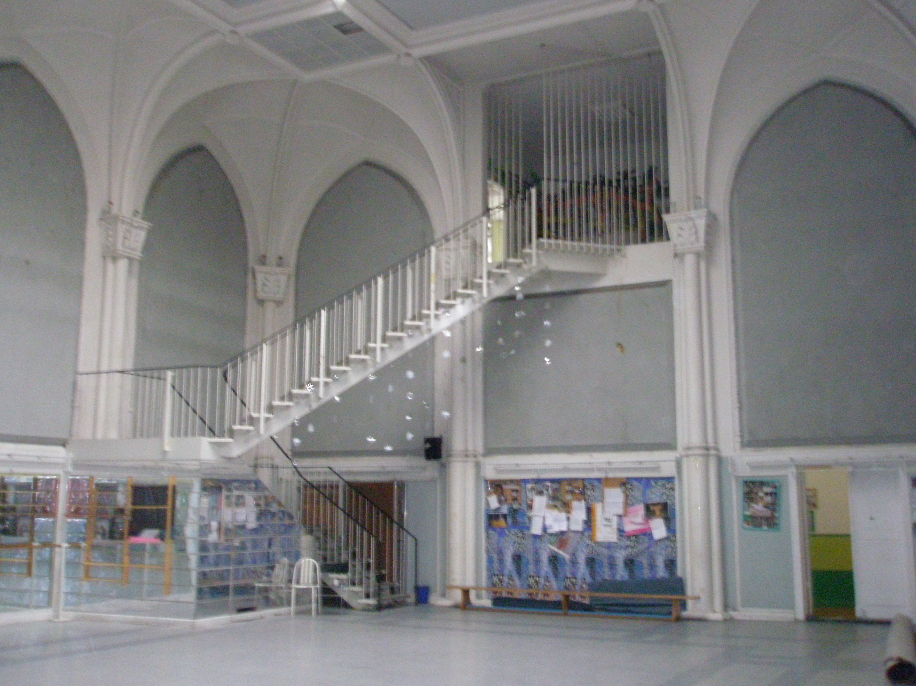
The big “Mirror hall”

