The Synagogue „Rykestraße“

The picture of the synagogue, that is shown while, Rosa talks about her marriage is not actually the “New Synagogue” from the “Oranienburger Straße”.
It is a picture of the synagogue “Rykestrasse”, which was built in 1903-1904 and redecorated in 2007.
The synagogue which is located in North-East Berlin once had 2000 seats, but still today, with its 1200 seats it is the biggest German synagogue.
During the night of November 9th it was set on fire but then extinguished again because of its location in a backyard.
Nevertheless it was confiscated by the Nazis in 1940.
Right after the Shoa it was used by the East German Jewish community again.
The synagogue in “Prenzlauer berg” (an eastern quarter of berlin) is also habitat of the Midrasha.
Especially tourists come to visit it because of its beauty and authentic.
There were only three pictures of the original synagogue from 1903 but still survivors that once prayed there attest the similarity of the redecorated building.
It was seen as a miracle that especially this synagogue was rebuilt and inaugurated 60 Years after the Shoa.
The pictures show the backyard and the great prayer room.

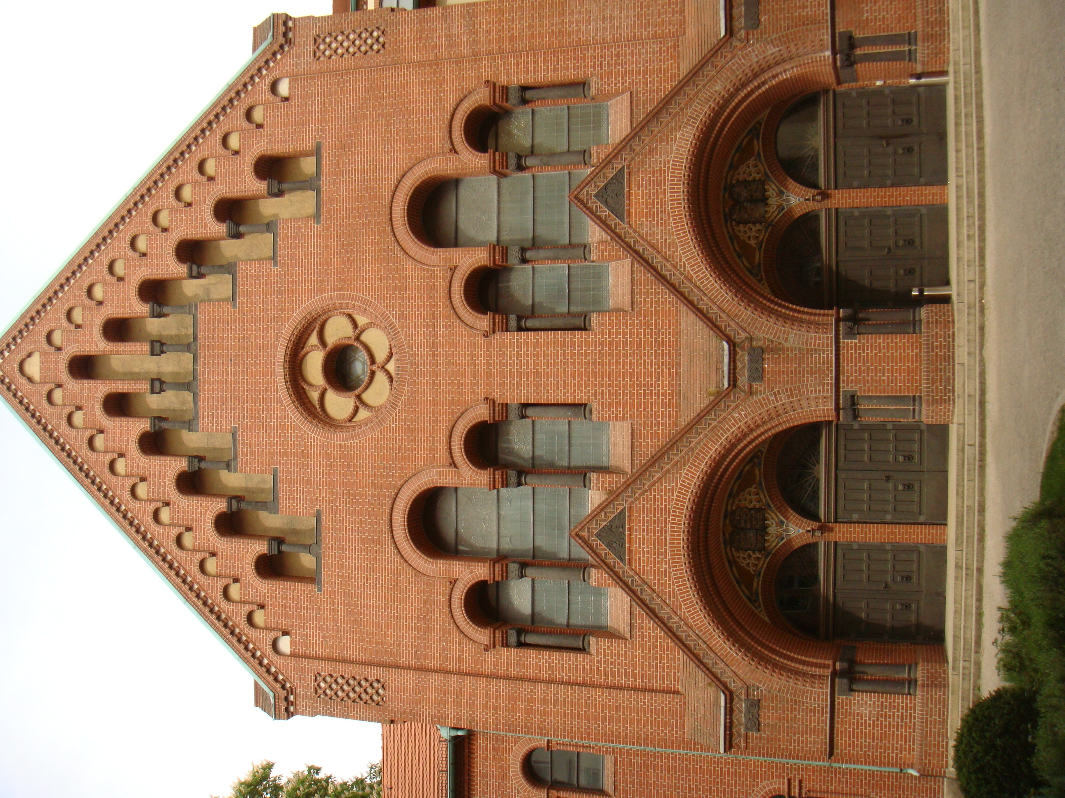

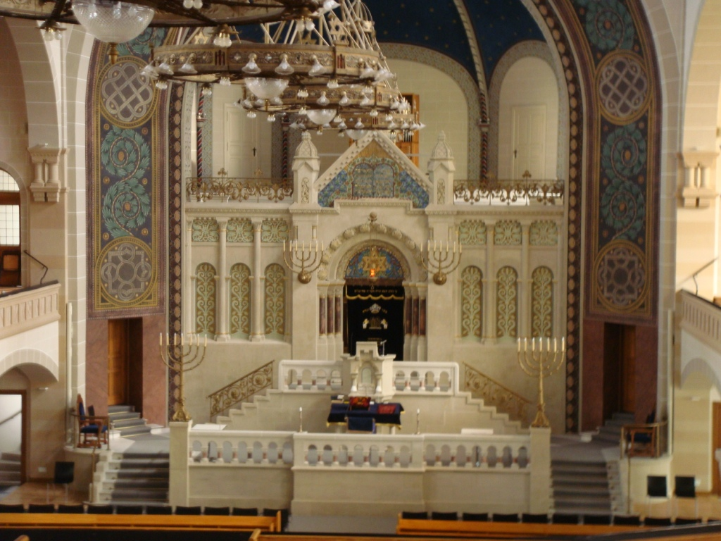

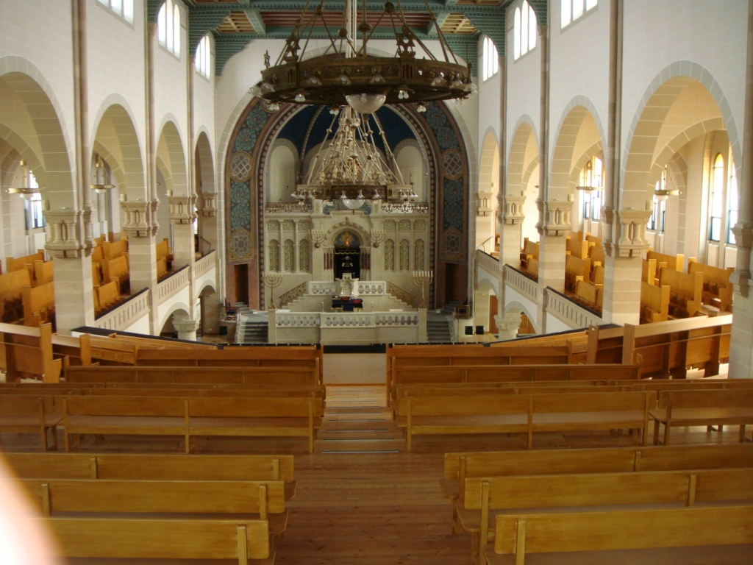
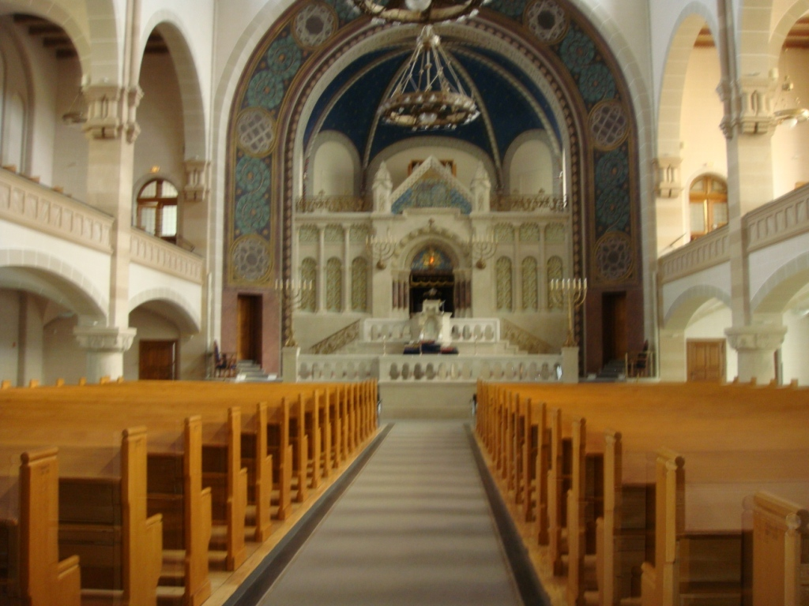

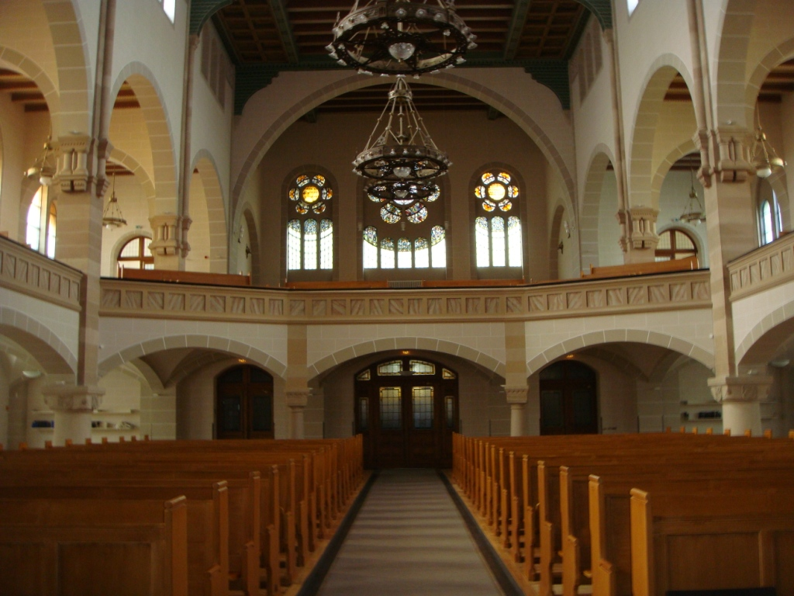

Address:
Synagoge Rykestrasse
Rykestrasse 53
10405 Berlin
Kabbalat Shabbat ( Friday )
winter ( nov. - march) : 6 pm
summer ( april - oct. ) : 7 pm
Shabbat Shacharit (Saturday) 9.30 am
liberal-conservative
Opening times for public visits
Thursday 2 pm - 6 pm
Sunday 1 pm - 5 pm
Latest admission: 5.30 pm / 4.30 pm

