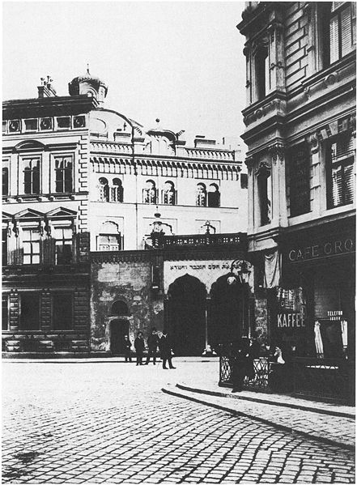
The Zirkusgasse Synagogue

History

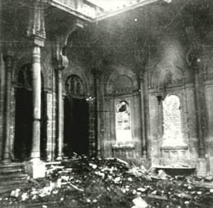
The Turkish Jewish community in Vienna was established in 1739 and received numerous exclusive rights from emperor Karl VI. Special arrangements with the Ottoman Empire were of great advantage. The Turkish Jews in Vienna considered themselves as the elite of Judaism and preferred to maintain the Sephardic rites and their Judaeo-Spanish language. The first temple of the Turkish-Jewish community is known to have been founded in1778; its location is, however, unknown. In 1824 the old temple was relocated from Obere Donaustraße to Große Mohrengasse after it had been destroyed by a fire.
The number of members rose enormously and the community purchased a new piece of land in Fuhrmanngasse 22, today Zirkusgasse. There, the new temple was built and opened in 1868. The new building had to be demolished again because defects in the construction were noticed. Hugo von Wiedenfeld was commissioned with the planning of the new synagogue. He managed to complete it between 1885 and 1887. In 1890 the Turkish Jewish community lost its independence due to the new Israelite Law and it was to be integrated in the Israelitic Cultural Community. After long negotiations the Sephardic community was provided with a certain amount of autonomy so that they could continue to maintain their own community register. After rabbi Michael Papo and since 1918 the rabbinate was barely occupied. The synagogue was destroyed during the pogrom night in November 1938. In 1988 the City of Viennaset up a Memorial Plaque in memory of the synagogue.

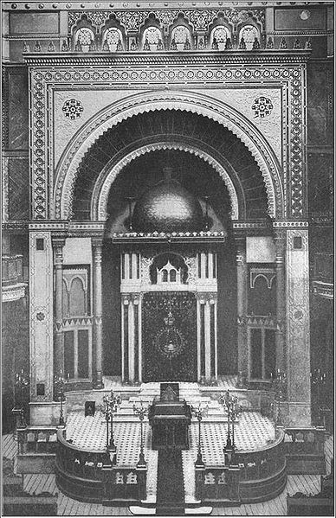
The building

The synagogue was built by Hugo von Wiedenfeld in the Moorish style after the model of the Alhambra. The entrance could only be reached through an inner court yard because the synagogue had been built between several neighbouring houses. The entrance led directly to a foyer and from there to the actual temple with its octagonal dome. It was supported by 17-metre high curtain walls and lit by a transom window and lanterns. The sanctuary was lined with marble or decorated with stucco and kept in gold or other colours. Opposite the sanctuary was the organ loft. The temple provided 314 seats on the first floor while on the galleries there was enough space for another 360 people offering 250 standing places and 110 seats. The synagogue also included a prayer room for the winter with another 105 seats.

