Holocaust Education, Jewish History and New Technologies in Hungary
Centropa seminar for teachers
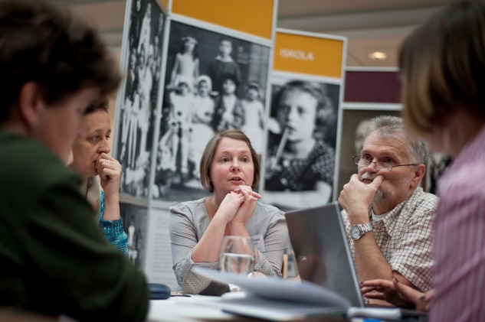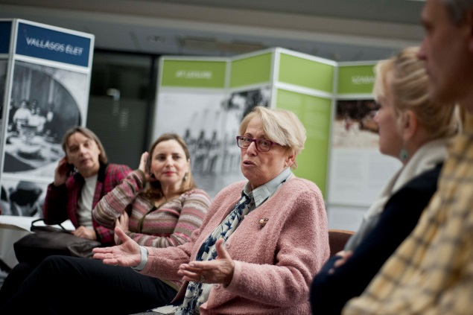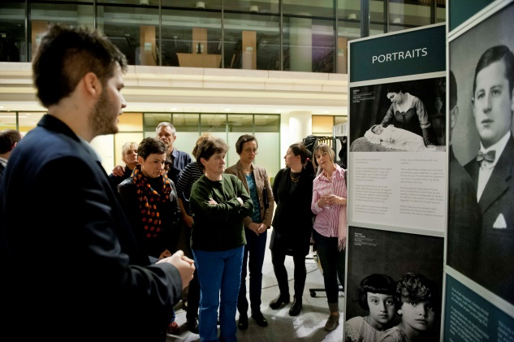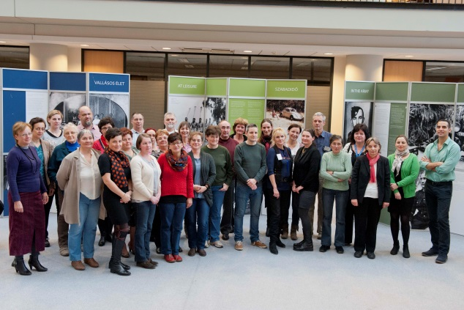
Date: 21 - 23 November, 2014
Location: University of Szeged
Number of participants: 31

Underwritten by:

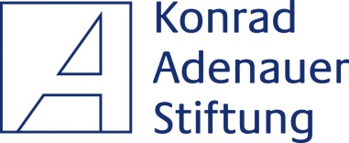 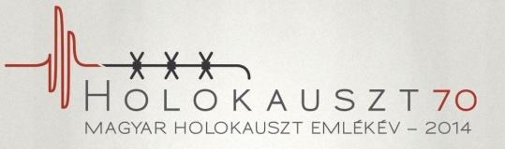 Gallic Foundation
Table of content
Executive summary 3
Ten take-away quotes 4
Participants 5
Question: What do you teach? 5
Question: How old are your students? 6
List of participants 7
What makes us different? 9
Question: Which seminars have you attended about Holocaust education before? 9
Question: Do you feel Centropa’s way of using personal stories will have an impact on your students? 10
Question: Participants were divided into smaller groups to work on lesson plans. Did you find this useful? 11
Turning our digitized archive into content - our films 11
Question: Which of our films will you use in class? 12
Question: Do you know of any other programs that take an entire family story and turn it into a mini-biographical film that you can use in the same way as these Centropa films? 12
Question: Do you think Centropa's short biographical multimedia films are successful with your students, and do you feel they promote tolerance among younger Hungarians today? 13
Practical tools for the teacher – our traveling exhibition and video making competition 14
Question: Do you think this exhibit can be an effective teaching tool for you in showing your students a broad view of Jewish life other than typical stereotypes? 14
Question: we asked Nóra Baracs and Bernadett Csehi to show how they involved their students to be guides for the exhibition. How did you find the tour and the method she used? 15
Question: This year we organize for the third time our video competition "Our Towns Jewish history". Can this be interesting for you and your students? 16
Café Centropa – where students and survivors meet 17
Question: On Sunday we introduced our Café Centropa program and we invited one of our interviewees, Olga Sólyom for a discussion. Do you think your students would be interested to meet with a survivor personally? 17
Seminar program 18
Budget 19

Executive summary

Centropa offers teachers inter-related educational tools: multimedia films and a traveling exhibition based on our interviews, video competitions and other student project ideas, an internet site that contains all of the above, and a platform for teachers where they can share ideas and best practices.
We help educators by offering seminars that provide them with historical knowledge, expose them to our online resources and give them the opportunity to collaborate with other teachers. This report provides an overview on our seminar held in Szeged with thirty-one participants, 21-23 November, 2014.
We chose Szeged as our seminar location because we wanted to strengthen our partnership with teachers from the countryside. By bringing both our exhibition and our seminar to Szeged we gained new partners, and established stronger bonds with our existing partners in the region.
Here are the most interesting facts from our survey:
- 90% of the participants said that Centropa’s way of using personal stories will have an impact on their students;
- 87% of the participants said that is was very useful to work on lesson plans in smaller groups;
- 83% of the participants said that Centropa's short biographical multimedia films are successful with their students, and they feel they promote tolerance among younger Hungarians today.
This report explains how we conducted our seminar, what we accomplished, and how we work with teachers to develop fresh methods for teaching 20th century history to Hungarian students.
Thank you for reading this through and feel free to contact me should you have any questions.
Sincerely,
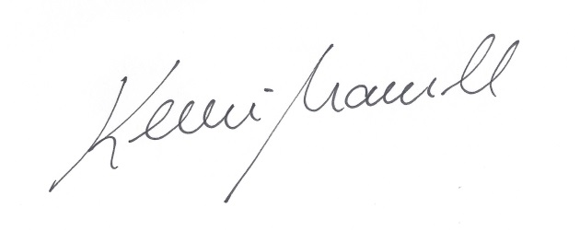

Marcell Kenesei
Director
Centropa Hungary

Ten take-away quotes

“It was good to get to know other colleagues, their problems and the different ways of teaching. I got many new ideas, and I will try to implement those in my school. I especially liked the presentation on the video making competition; I think that’s a fabulous project.”– Tóthné Bertalan Éva, Szeged
“I could get to know shocking fates, fates of people that were determined by history. Through Centropa these people became my personal friends; I laughed, cried, mourned… these stories help makes us re-live history, and be part of these people’s lives – and that’s a very useful weapon in education” – Pingitzer Andrea, Pápa
“The seminar was very well thought out – the aims were clear, the content provided was meaningful, and the educational materials are very easy to use” – Hajduné Bihari Ágnes, Szeged
“I was very happy to get to know this unique approach to Holocaust education. I have many colleagues in my school who are ignorant or very much against teaching this topic. These three days and the Centropa materials gave me courage and ideas of how to reform Holocaust education in our school” – Balássy Dávid, Budapest
“Thanks to your humble and professional work I learned lot of new things, heard new ideas, and gained new friends and contacts. Thank you for enriching our work by organizing this seminar” – Varga Péter, Budapest
“This seminar was a perfect opportunity to recharge my batteries. Its important for me to see that I’m not the only one who is trying to deal with this subject, it gives me courage to continue my work fighting anti-Semitism. Spending this weekend with these devoted and great teachers reassured me in a lot of ways” – Barnáné Nagy Angéla, Kalocsa
“I liked it very much that Centropa treated us like real partners. They showed us opportunities which we can choose from, and adapt them to our ideas. It was also nice to see that Centropa wanted to hear our opinion as well. This really defined the good mood, and you were well prepared and empathetic which made this a very rewarding experience” – Fügedi Anna Petra, Szeged
“Thinking and working together gave me a lot of new ideas. During this seminar we really heard useful and practical ideas.” – Sánta Katalin, Budapest
“In my experience any subject can be made more interesting if there is a personal aspect to it. Today’s teenagers do not know anyone who lived through these difficult times, so Centropa makes a perfect job in filling this gap.” – Dr. Tóthné Hegyi Valéria, Mezőkövesd
“I think its very important that Centropa not only acknowledges that we live in a digital age but also uses new technologies, makes teaching interactive – in other words: Centropa speaks the language of the younger generation” – Tevan Ildikó, Budapest

Participants

Question: What do you teach?
Most of the respondents work as history teachers but they also teach a wide variety of other subjects. Responses in the ‘other’ category include: special education teacher, computer science, mathematics, physics, chemistry, folklore studies, school librarian, educational coordinator.
- History – 45,16% (14)
- Hungarian literature and grammar – 41,94% (13)
- Social studies – 12.9% (4)
- English – 3,23% (1)
- German – 12,9% (4)
- Elementary school teacher – 9,68% (3)
- Other – 41,94% (13)
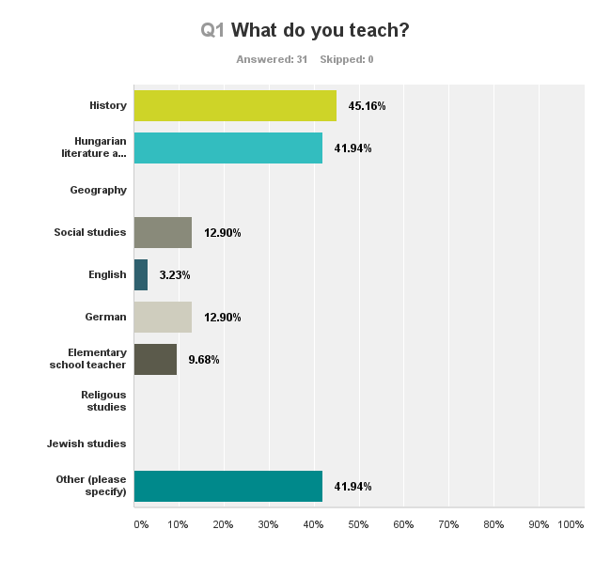

Question: How old are your students?
A substantial majority of the educators work as high school teachers, and at this seminar almost 50 % of the participants work as elementary school teachers as well. Although Centropa works mainly in high schools, in the last few years there has been a growing interest from all kinds of educators in Hungary to use our materials, and initiate projects based on Centropa’s methods
- Elementary school – 48,39% (15)
- High school (7th, 8th, 9th grade) – 51,61% (16)
- High school (10th, 11th, 12th grade) – 58,06% (18)
- University – 3,23% (1)
- Other – 6,45% (2)

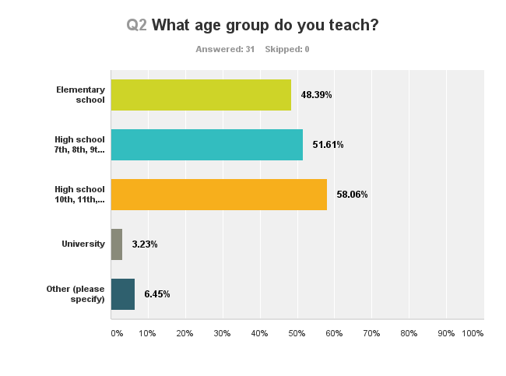

List of participants
City | Name | School/institution | Courses taught
Arad | Péter András | Nagyiratosi Elementary School | physics, chemistry
Budapest | Vida Katalin | Bilingual School of Erzsébetváros | Hungarian literature and grammar, history
Budapest | Sánta Katalin | Arany János School | Hungarian literature and grammar, mathematics, science, and German
Budapest | Tevan Ildikó | Wesley János Institute | computer science, cultural organizer
Budapest | Varga Péter Pál | Wesley János Institute | history, German
Budapest | Balássy Dávid | Nagykovácsi Általános Iskolá | elementary school teacher, computer science
Budapest | Sánta Zoltán András | Wesselényi Vocational School | Basic economy, and media studies
Budapest | Töltésiné Hegyi Zsuzsanna | Bláthy Ottó Informatikai Szakközépiskolá | computer science, librarian
Budapest | Baglyos Natália | Sztehlo Gábor School | German, mathematics
Budapest | Baglyos Nóra | Szent György Greek Catholic School | Hungarian literature and grammar
Cegléd | Radácsi Éva | Unghváry László Vocational School | Hungarian literature and grammar, history, social studies
Gyöngyös | Nagyné Petrovics Tünde | Petőfi Sándor Vocational School and Institute for Special Education | history, special education teacher
Kalocsa | Barnáné Nagy Angéla | Kalocsai Nebuló School, Vocational School, and Institute for Special Education | history
Mezőkövesd | dr. Tóthné Hegyi Valéria | Szent László School | Hungarian literature and grammar, history
Nyíregyháza | Páll Csilla | Krúdy Gyula School | Hungarian literature and grammar, history
Nyíregyháza | Kéner Beatrix | Krúdy Gyula School | Hungarian literature and grammar, history
Oroszlány | Kertész Ágnes | Benedek Elek School, Vocational School and College, and Institute for Special Education | special education teacher, Roma studies
Oroszlány | Földiné Szakács Zsuzsanna | Benedek Elek School, Vocational School and College, and Institute for Special Education | special education teacher, ethics
Oroszlány | Nagy Ildikó | Klebersberg Kuno Institute | educational coordinator
Oroszlány | Járfás Mihály | Hunyadi János School | history, ethics
Pápa | Pingitzer Andrea | Türr István School | Hungarian literature and grammar, history
Pécs | Baracs Nóra | Széchenyi István School | history
Piliscsaba | Bakos Nagy Márta | Dr. Szepesi László Vocational School | Hungarian literature and grammar, history, English
Salgótarján | Filkorné Herczeg Katalin | Uzoni Péter School | mathematics
Salgótarján | Pásztor Fruzsina | Uzoni Péter School | Hungarian literature and grammar, history
Sopron | Robotka Csaba | Széchenyi István School | history, social studies
Sopron | Csehi Bernadett | Petőfi Sándor School | Hungarian literature and grammar, German
Szeged | Fügedi Petra Anna | ELTE University | coordinator of educational programs
Szeged | Milosné Domokos Ilona | Radnóti Miklós School | history, German
Szeged | Tóthné Bertalan Éva | Kossuth Zsuzsanna Vocational School | mathematics, physics, computer science
Szeged | Hajduné Bihari Ágnes Klára | Móraváros Vocational School | psychology

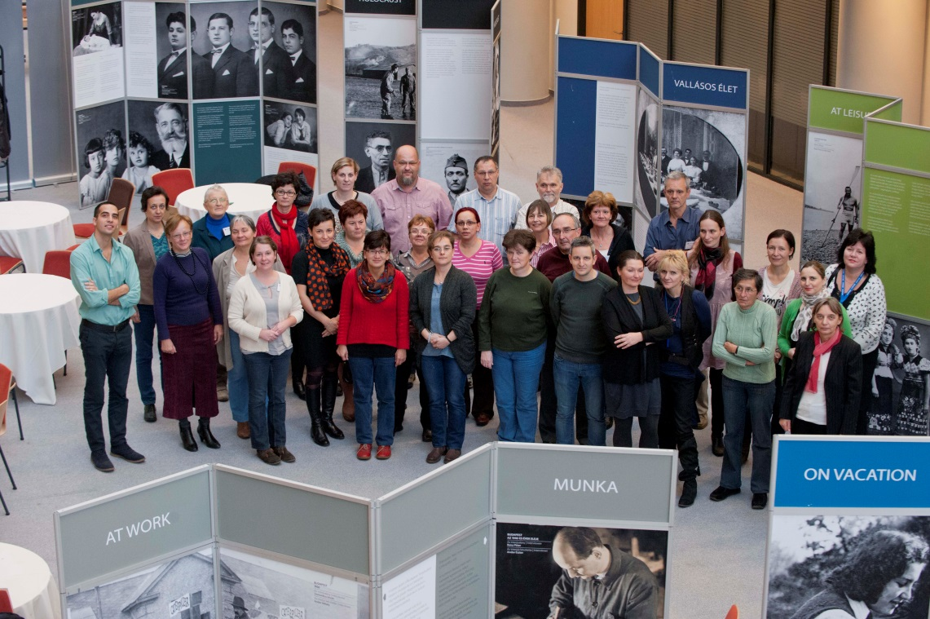

What makes us different?
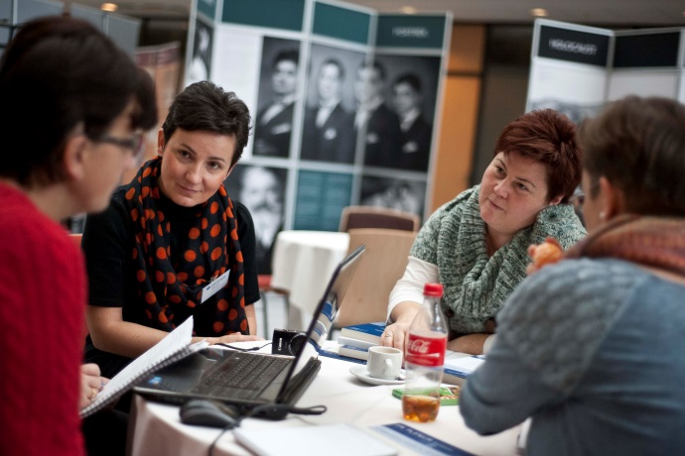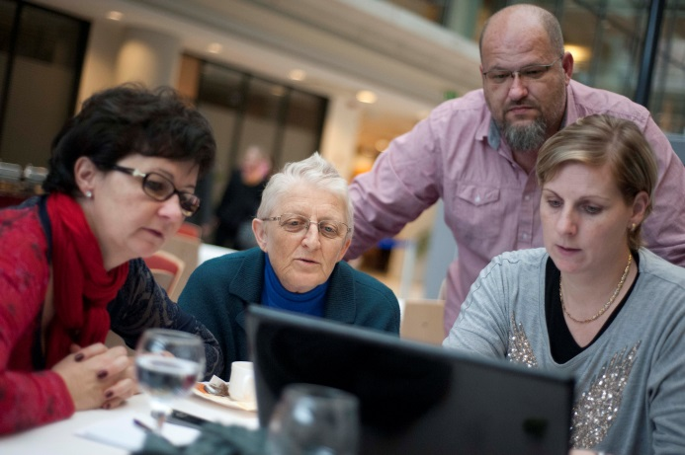
Centropa seminars are very practical. At our seminars we bring teachers around the table to watch our educational multimedia films, and then walk through our exhibitions, and afterwards, we have them compare notes, share best practices and brainstorm with each other. Then they write up lesson plans that they share with each other. That way, we create teacher buy-in. And we strongly believe that teachers really do know what their students will like, because they are on the front lines of teaching every day.
We asked our partner teachers if they had attended other seminars on Holocaust education and we also asked them about the methods we use. From the answers we can see that the majority of the participants were not completely new to Holocaust studies, they attended other seminars before. For seven teachers this was the very first time they dealt with this subject. The answers also show that teachers appreciate the way we operate our programs; 90 % think that the way we use personal story telling will have an impact on their students, and 87% said it was absolutely useful to work on lesson plans in smaller groups.

Question: Which seminars have you attended about Holocaust education before?
- Yad Vashem – 51,61% (16)
- Seminar or workshop in Hungary – 54,84% (17)
- Seminar or workshop in other place – 19,35% (6)
- I have not attended a Holocaust education seminar before – 22,58% (7)

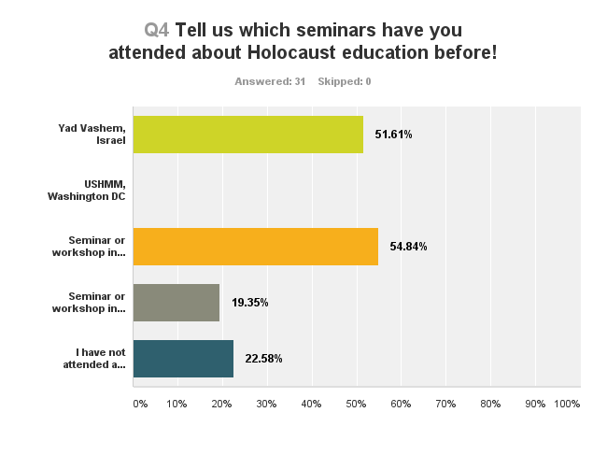

Question: Do you feel Centropa’s way of using personal stories will have an impact on your students?
- Yes, I think so – 90,32% (28)
- Possibly – 6,45% (2)
- Maybe – 3,23% (1)
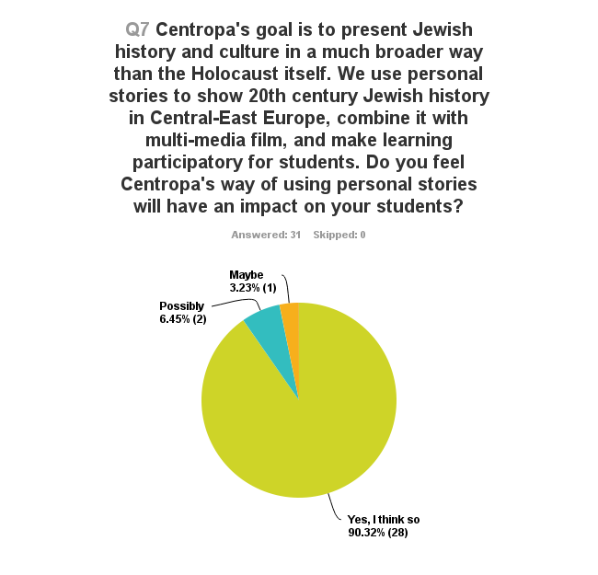

Question: Participants were divided into smaller groups to work on lesson plans. Did you find this useful?
- Absolutely – 87,1% (27)
- To some extent – 9,68% (3)
- Wasn’t able to attend – 3,23% (1)
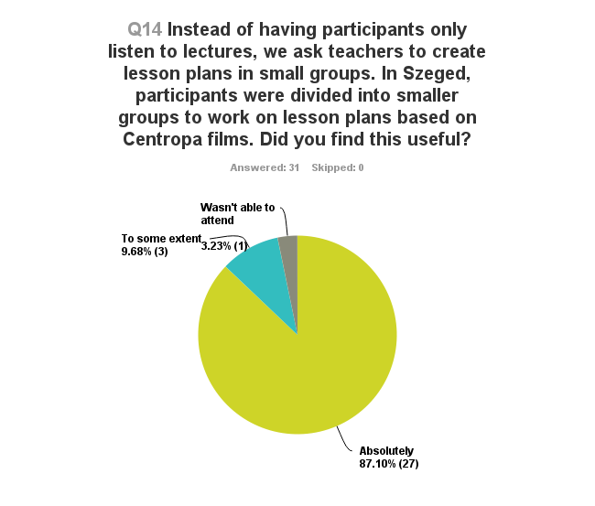

Turning our digitized archive into content - our films
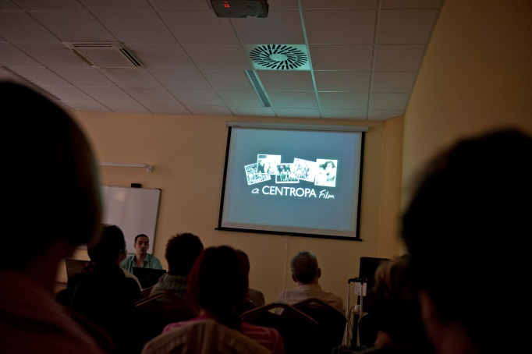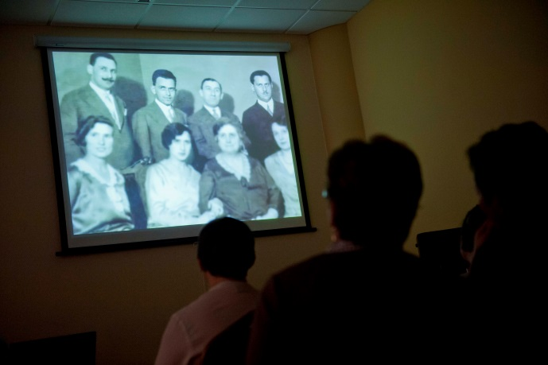
Centropa films combine the old family pictures our interviewees allowed us to digitize with the stories they told us about the people in those pictures. Our films take us back into a world destroyed, but also bring us all the way to the present. A substantial majority of those teachers who used our films found them to be effective tools for education.
In our survey we asked the participants if they found our films useful, how they think it will impact their students, and we also asked them to give us honest feedback on our newest multimedia film. Our most popular film is “Love on a paper airplane” about Judit Kinszki. More than 50% of the respondents never watched films like ours, and 84% said that these films can promote tolerance among young Hungarians.

Question: Which of our films will you use in class?
- Introduction on Hungarian Jewish history – 61,29% (19)
- Kinszki Judit – 83,87% (26)
- Faludi József – 35,48% (11)
- Katarina Löfflerová – 38,71% (12)
- Nussbaum László – 61,29% (19)
- Domonkos István – 61,29% (19)
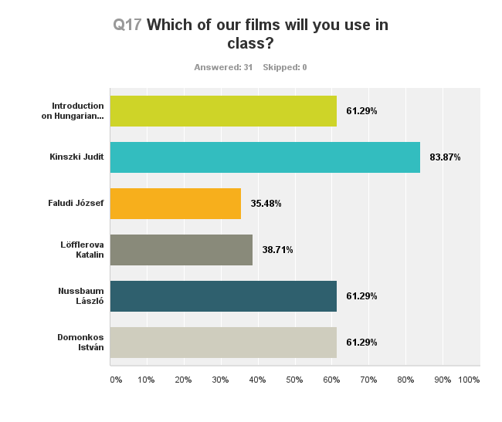

Question: Do you know of any other programs that take an entire family story and turn it into a mini-biographical film that you can use in the same way as these Centropa films?
- No I don't know of any other programs that offer life stories like this – 54,84% (17)
- I have seen some video interviews with Holocaust survivors but they are entirely about the Holocaust itself – 35,48% (11)
- Yes, I have seen other films like these – 9,68% (3)
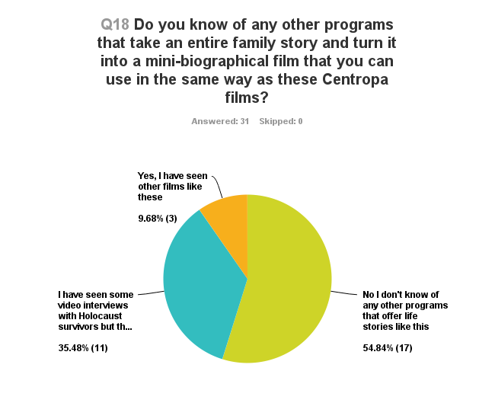

Question: Do you think Centropa's short biographical multimedia films are successful with your students, and do you feel they promote tolerance among younger Hungarians today?
- Yes, definitely – 83,87% (26)
- Perhaps – 16,13% (5)
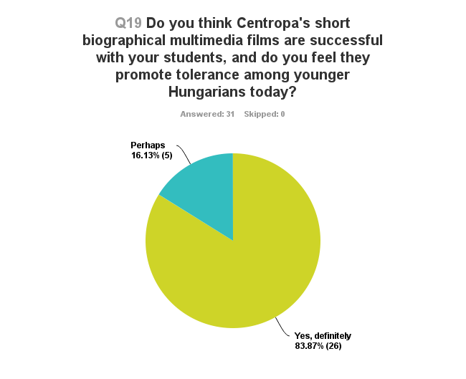

Practical tools for the teacher – our traveling exhibition and video making competition
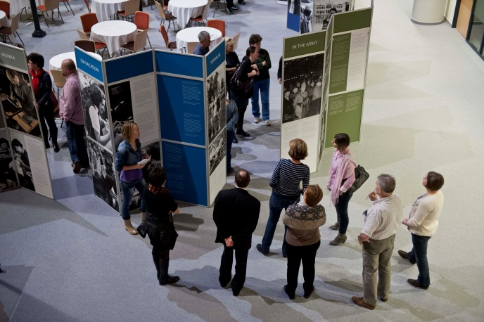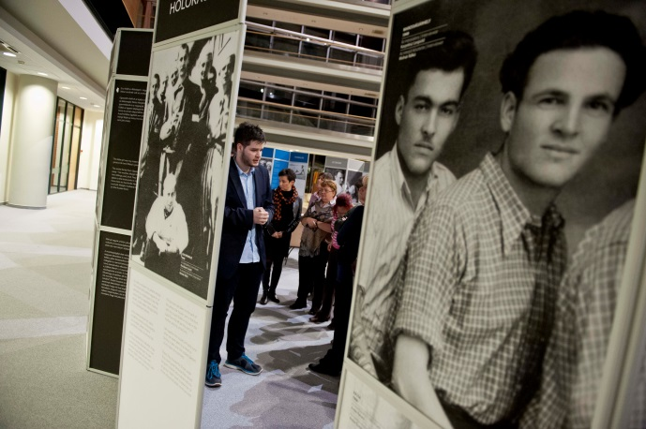
Centropa created a traveling exhibition based on our interviews and old family photos. We divide the most interesting pictures and stories into categories such as in school, at work, on vacation, at leisure, religious life, in the army, portraits and Holocaust, and then next to each photo we print the accompanying story as told by the survivor. Visiting a Centropa exhibition is like walking through a giant family album, and thanks to our Hungarian teachers we have developed several ideas for using this exhibition in schools.
We asked the participants what they thought of the exhibition, the methods to use it shown by two of our veteran teachers, and we also asked them if they would like to bring it to their school at some point. 77% of the respondents said they very much would like to bring it to their school, and a vast majority of the respondents rated the student guided tour method as excellent or good.
We also introduced them to the "Our Town's Jewish History” video competition project where students tell stories of the Jewish history of their cities, towns, neighborhoods in 5-10 minutes videos. They do their own research, collect photos, write the script, tell the story in English, and then upload them on the Centropa Border Jumping site, an interactive project page where students from other countries can also watch and learn from these films. 50% of the respondents said this would be interesting for them and their students and only 5 participants responded that they don’t think they will be part of it.

Question: Do you think this exhibition can be an effective teaching tool for you in showing your students a broad view of Jewish life other than typical stereotypes?
- Very much and I would like to bring it to my school – 77,42% (24)
- I'm interested but I don't think it will fit in my school. We would need to find a nearby location – 12,9% (4)
- I’m not interested in this – 9,68% (3)
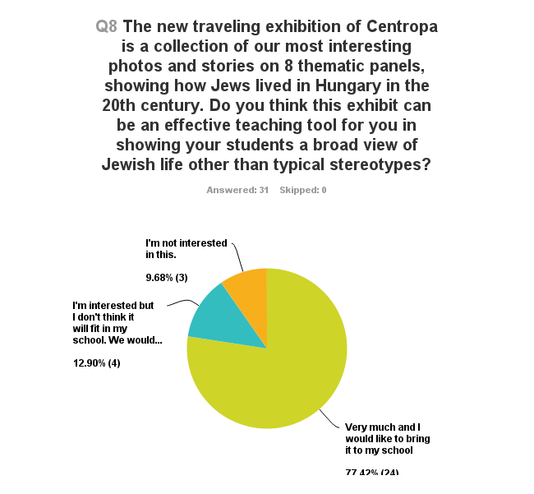

Question: we asked Nóra Baracs and Bernadett Csehi to show how they involved their students to be guides for the exhibition. How did you find the tour and the method they used?
- Excellent – 29,03% (9)
- Good – 51,61% (16)
- Fairly good – 9,68% (3)
- I wasn’t able to attend – 9,68% (3)
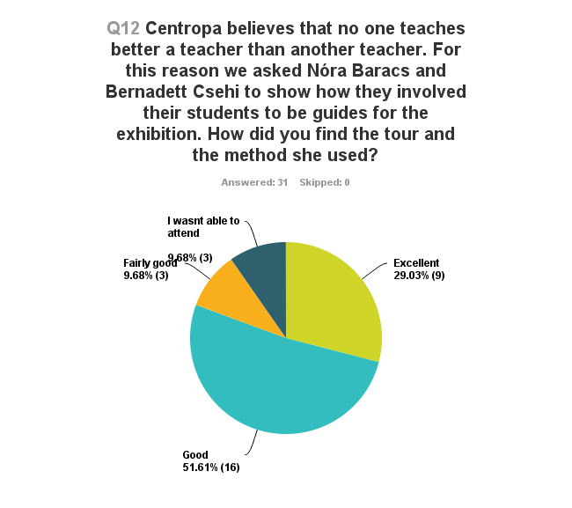

Question: This year we organized for the third time our video competition "Our Towns Jewish history". Can this be interesting for you and your students?
- Yes, I think so – 48,39% (15)
- Possibly – 12,9% (4)
- Maybe – 22,58% (7)
- I don’t think so – 16,13% (5)
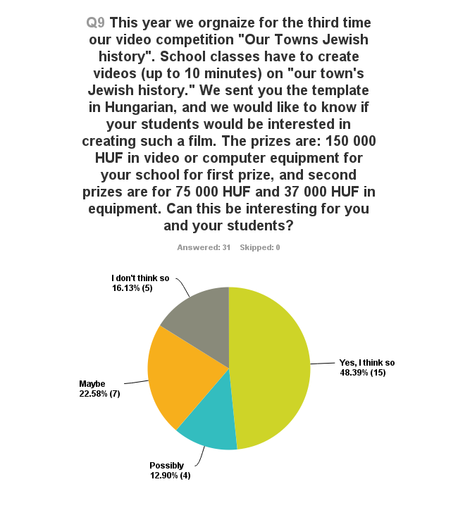

Café Centropa – where students and survivors meet

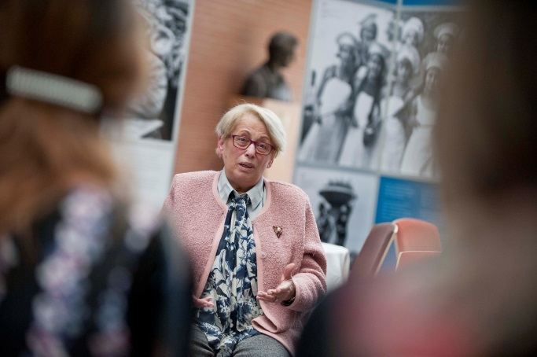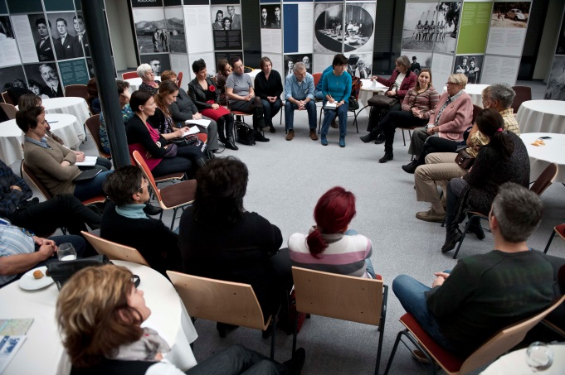
To close our program we invited Olga Sólyom, a Centropa interviewee to talk about her life. Centropa combines our social club for our elderly with our educational programs. This is a unique and special opportunity for students. They can ask questions and have an intimate conversation with a Holocaust survivor.
We see from the responses that meeting Olga made the seminar participants very emotional. 71% said that they definitely want to give this kind of experience to their students as well.

Question: On Sunday we introduced our Café Centropa program and we invited one of our interviewees, Olga Sólyom for a discussion. Do you think your students would be interested to meet with a survivor personally?
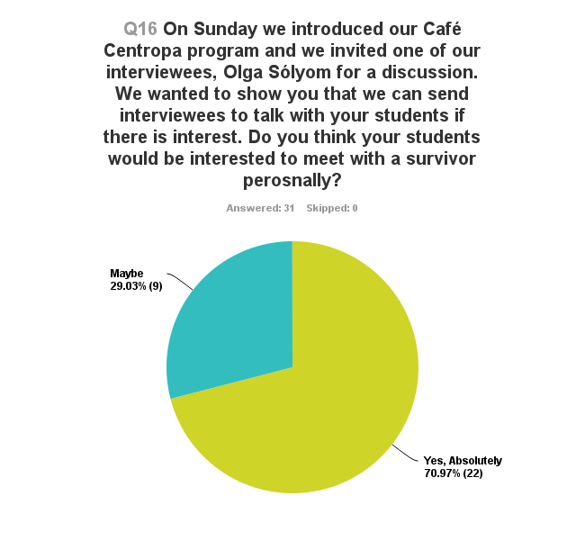

Seminar program

21. November, Friday
16:00 – 17:00 Registration
17:00 – 18:00 Welcoming remarks, introduction of teachers
19:00 – 20:00 Dinner hosted by the Jewish Community of Szeged
22. November, Saturday
8:30 – 9:45 Introduction to the work of Centropa – showing our online database of oral history interviews, family photographs, and educational materials based on that. Moderator: Marcell Kenesei and dr. Szilvia Czingel
9:45 – 10:45 Showing four Centropa educational multimedia film followed by discussion. Moderators: Marcell Kenesei and Szilvia Czingel
10:45 – 11:15 Lecture on how to use Centropa films in education
Presenters: Bernadett Csehi from Sopron and Nóra Baracs from Pécs, history teachers
11:15 – 11:30 Coffee break.
11:30 – 13:00 Group work on how to use multimedia films in education. During this session participants create lesson plans and projects.
13:00 – 14:30 Lunch
14:30 – 16:00 Presenting and discussing created lesson plans and project ideas
16:00 – 16:40 Introduction of Zachor Foundation. Presentation of Nárcisz Vida
16:40 – 17:40 Showing of our traveling exhibition, „Pictures from a family album” with the help of two of our veteran teachers and their students who were trained to be tour guides for the exhibition
17:40 – 18:20 How to use the exhibition in education? Presentation by two of our veteran teachers.
Presenters: Bernadett Csehi and Nóra Baracs
18:20 Dinner.
22. November, Sunday
8:30 – 9:15 Introduction to Centropa’s video making competition, „Our Town’s Jewish History”, presentation on how to do video projects and fill them with educational content. Presentation by Natália Baglyos
9:15 – 10:30 Showing our newest educational multimedia film on the life of Miksa Domonkos, followed by discussion.
10:30 – 10:45 Coffee break
10:45 – 12:00 Presenting our Café Centropa program, followed by a round table discussion with Centropa interviewee Olga Sólyom
12:00 – 13:00 Feedback and closing remarks
Moderated by Marcell Kenesei and dr. Szilvia Czingel
13:00 Seminar ends.

Budget

Expenses | HUF | EUR
Accommodation | 842150 | 2716,613
Catering | 712040 | 2296,903
Rent of seminar space | 202500 | 653,2258
Photographer | 127000 | 409,6774
Exhibition transfer | 63500 | 204,8387
Welcome package | 14711 | 47,45484
Travel expenses | 260000 | 838,7097
Seminar assistant | 80000 | 258,0645
Staff time - director Centropa Hungary | 200000 | 645,1613
Total | 2501901 | 8070,648
Incomes | HUF | EUR
Konrad Adenauer Stiftung | 1700000 | 5500
Gallic Foundation | 500000 | 1600
Holocaust Memorial Year Fund | 301901 | 970
Total | 2501901 | 8070

