The Centropa feedback Seminar
Holocaust Education, Jewish History and New Technologies in Hungary
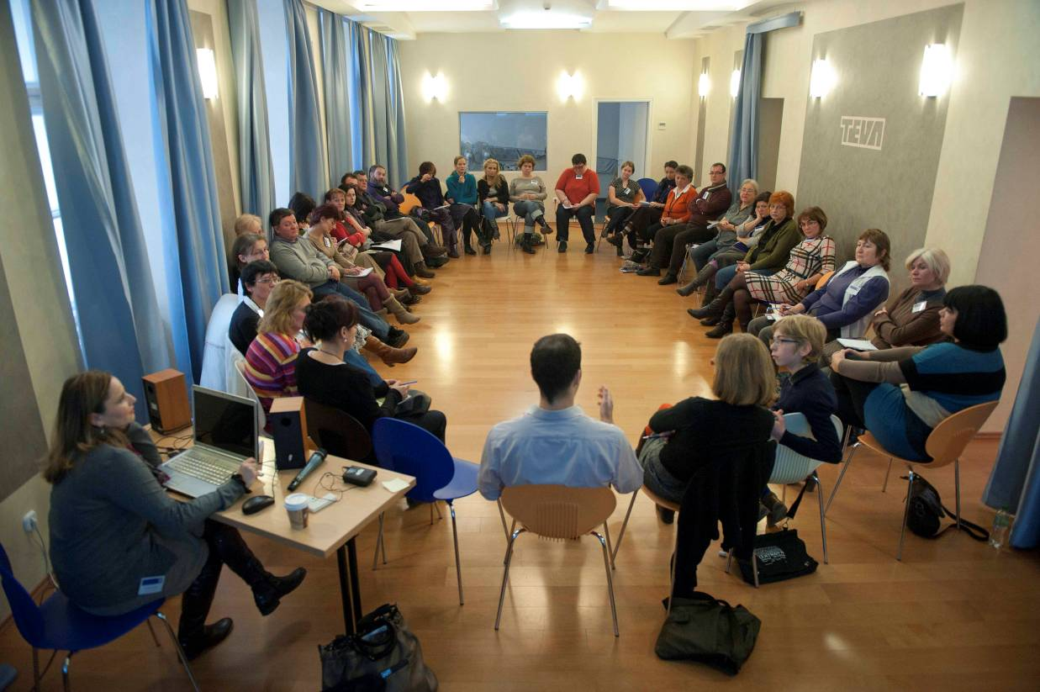
Date: 7-9 December, 2012
Location: Israeli Cultural Institute, Budapest
Number of participants: 39
Underwritten by:
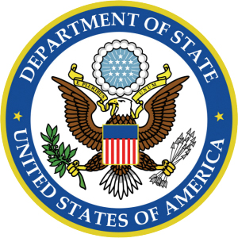
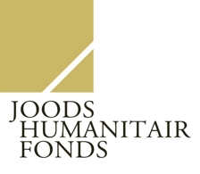
Table of content

Executive summary………………………………………………………………………………………………………page 3
Participants……………………………………………………………………………………………………………….....page 4
About Centropa Hungary……………………………………………………………………………………………...page 6
Annoted seminar program…………………………………………………………………………………………....page 7
Background info…………………………………………………………………………………………………………...page 9
Lesson plan presentation…………………………………………………………………………………………....page 12
Project presentation…………………………………………………………………………………………………...page 17
Workshop with Haver and Uccu foundations……………………………………………………………….page 22
Joint Hanukah event with “Café Centropa”…………………………………………………………………...page 23
Centropa films…………………………………………………………………………………………………………....page 24
Outcomes and results………………………………………………………………………………………………....page 25
Budget…………………………………………………………………………………………………………………….…page 26
Partners and sponsors……………………………………………………………………………………………..…page 27
Executive summary

Over the period of the last five years Centropa Hungary organized several teacher training seminars. We offer teachers inter-related educational tools: a database of 200 oral history interviews together with family photos, mulitmedia films based on interviews, an exhibition based on those interviews, and an internet site that contains all of the above.
We help educators use these tools by offering seminars that provide them with historical knowledge, expose them to our online resources and give them the opportunity to collaborate with other teachers.
During our seminars we started to build long-term partnerships with our participants, we asked them to try out the lesson plans and educational ideas they have developed during our programs, and aimed to do a continous follow-up with each one of them. At Centropa we belive that feedback from our teachers is crucial, and as part of our program we aimed to organize a seminar where we listened to lesson plans and projects that were initiated due to Centropa seminars.
At this seminar we invited teachers who already use Centropa materials in their classes. We asked several of our veteran teachers to present their lesson plans and projects that are based on Centropa materials, or inspired by Centropa-related programs.
Paticipants learned how these Centropa veteran teachers trained their students, how they made video projects with them, and how they use our database and materials on a regular basis. As part of the seminar they also gave personal feedback to the presented lesson plans and projects.
In this report we will share with you the feedback from 39 teachers who came to our seminar. Here is a summary of some of the most interesting statistics and facts:
- 97 % of the respondents feel that Centropa’s approach has a positive impact on their work
- 90 % of the respondents agreed completely that its useful to organize seminars only for veteran teachers
- 75% of the participating teachers signed up to do a project also next school year
- In this report you will see twelwe various lesson plans and projects that were presented during the seminar
This report explains how we conducted our seminar, what we accomplished, and how we work with teachers to develop fresh methods for teaching 20th century history to Hungarian students.
Thank you for reading this through and feel free to contact me should you have any questions.
Sincerely,

Marcell Kenesei
Director, Centropa’s Hungarian program
Participants
For this seminar we focused primarily on high school teachers who already use Centropa materials in their classes, and who were interested to hear other lesson plans, projects and educational methods.
Inviting teachers who already are familiar with Centropa enabled us to focus on concrete project ideas, discuss their experiences rather than introducing Centropa methods and explaining how our programs work in general. Like this we had the opportunity to get clear feedback what the teachers could use and how we can make oursevles better to help them even more.
Please note that although the official number of participants for this seminar is 39, in the surveys you will see there are 33 participants responding to the questions -- thats because we also listed 6 teachers who could not stay for the entire time, so they couldn’t give an evaluation on the whole program.
City | Institution | Name | Courses taught
Budapest | AKG - High School | Éva Kardos | history, social studies, german
Budapest | ELTE Radnóti Miklós School | Márta Ispánovity | history
Budapest | Bornemisza Péter High School | Tibor Pécsi | history
Budapest | 14. District, Wesselényi School | Katalin Szili | english, german
Budapest | Puskás Ferenc Elemantary School | Márta Eöry | elementary school teacher (1-4 grade)
Budapest | Sztehlo Gábor Evangelical high School | Natália Baglyos | German, Mathematics
Budapest | Budapest Collage of Communication and Bussiness | Horváth L Katalin | special education programs
Budapest | Budai Nagy Antal High School | Éva Tóth Vásárhelyi | History, social sciences, ethics, philosophy
Budapest | Bornemisza Péter High School | Anna Borók | elementary school teacher
Budapest | Népszabadság / Budapest College of Communications | Gabi Valakczkay | Journalist, educational advisor at
Budapest | Fazekas Mihály School | Tamás Foki | History, literature
Budapest | Kossuth Lajos Műszaki SZKI | Eszter Vági | Theater and drama classes
Budapest | Lauder Javne School | Cili Horváth | History
Budapest | Lauder Javne School | Ágnes Fenyő | Hebrew
Budapest | Toldy Ferenc School | Péter Molnár | History
Debrecen | KL Tudomány University | Zsolt Heller | Jewish folclore
Érd | Egressy Gábor High School in Zugló | László Gregus | psychology
Esztergom | Dobó Katalin Hihg School | Péter Kindler | history, German
Füzesabony | Besenyő Teleki Cultural and Educational Center | Mária Erdélyiné Gál | history and literature
Kalocsa | Szent István High school | Dr. Gyöngyi Magóné Tóth | history
Kaposvár | Somogyvár Elementary School, Special and Vocational School | Ágnes Kircz | special teacher
Mezőberény | Petőfi Sándor High School | Andrea Komódi | history, Hungarian literature, philosophy
Mezőcsát | Mezőcsát Protestant High School | Terézia Gulyás | history, literature, social studies, ethics, media
Miskolc | Me, Faculty of Law, Institute of Legal History | Veronika Lehotay
Mogyoród | High school for Economics in Mogyoród | Zoltán Sánta | history, Hungarian literature
Nyíregyháza | Medical University of Debrecen | Anriett Judit Jakab | non-discrimination, holocaust education
Olaszfalu | freelancer | Piroska V Dobosné | Organizer of educational programs in Olaszfalu
Pécs | Széchenyi István High School | Márta Nagy | German
Pécs | Széchenyi István High School | Nóra Baracs | history and social studies
Pécs | Apáczai Educational Center – Elementary school | Éva Hajnal | literature, music, audio-visual arts, elementary school teacher
Pécs | Simonyi Károly Vocational School | Beáta Bartha | history, social studies
Pécs | Simonyi Károly Vocational School | Marianna Beregszászi | history, social studies
Sopron | Roth Gyula Gyakorló High School and College | Zsolt Vódli | history, Hungarian literature, social studies
Sopron | Eötvös József Evangelical High School | Bernadett Csehi | Literature
Szedres | I. Béla Gimnázium - Szedresi Bezerédj István Elementary School | Mária Barteczka | history, librarian
Szombathely | University of West Hungary, Faculty of Arts | Gábor Murai | communication, social conflict, conflict management, and the Holocaust in the media
Szombathely | Szombathely Technical High School and College | Hedda Varga | history, social studies, library education
Szombathely | University of West Hungary, Faculty of Arts | Márta Goldmann | American Jewish literature
Zalaegerszeg | Zalaegerszeg College | Éva Juhász | German, pedagocial consultant

About Centropa Hungary

Centropa created a database of Hungarian Jewish memory – hundreds of interviews for students and teachers to read, and 4000 photographs to search through. In the last three years Centropa built our Hungarian education program in the following ways:
- produced three printed annual publications of Jewish history and culture, and eight online editions for our Hungarian website (www.centropa.hu);
- held one seminar for twelwe teachers employed in Jewish schools, working with them on using our multi-media films and showing them how to upload student work to our website (2009);
- conducted a seminar for twenty-one public school teachers on how to use our multimedia films (2010);
- provided a forum for public school teachers from Budapest, Prague and Bratislava by holding an international seminar where they could share best practices and establish partnerships with each other (2010);
- created a Hungarian language educational website that offers public and private school teachers stories and other educational tools regarding Hungarian Jewish culture;
- established “Café Centropa” where our Budapest interviewees meet regularly to enjoy each other and celebrate Jewish holidays;
- sponsored the participation of nine Hungarian teachers at our last three international summer academies, where they met and exchanged lesson ideas and pedagogical methods with teachers from the US, Europe and Israel
Annoted seminar program

7. December, Friday

17:00 Joint Hanukah celebration with Centropa interviewees
- Performance of Gólem Theatre
- Lecture of Dr. Gábor Balázs on Chanukkah
- Dinner at Kőleves restaurant
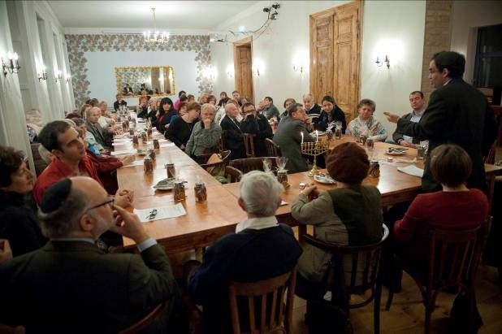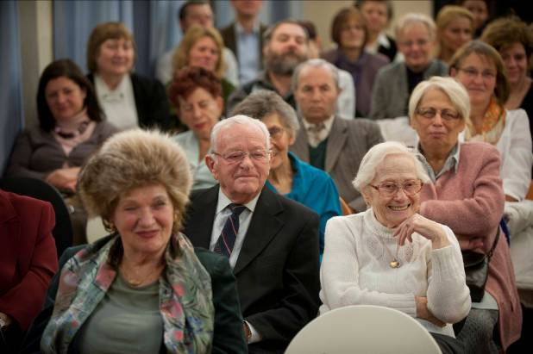
8. December, Saturday
9:00. “Where is Centropa today? The path we traveled. What are the future plans?” – Presentation on the work of Centropa by Dóra Sárdi and Marcell Kenesei
10:00. Presenting lesson plans. Each presenter had 15 minutes to present, and after that we heard feedback from the teachers. The presentations:
Tamás Foki, Fazekas Mihály School, Budapest – “Teaching Holocaust in my school”
Péter Kindler, Dobó Katalin School, Esztergom – “Using the story and film about Istvánné Szamosi”
Andrea Komódi, Petőfi Sándor School, Mezőberény – “Changing attidutes and raising interest with the help of Centropa”
11:00. Break
11:15. 2nd part of lesson plan presentations
Eszter Vági, Kossuth Lajos SZKI, Budapest – “Using documents and simple drama methods in class”
Bernadett Csehi, Eötvös József Evangelical School, Sopron – “How I use the film about József Faludi”
Tibor Pécsi, Bornemisza Péter School, Budapest – “Working with the Rosa Rosenstein film”

12:15. Lunch
13:15. Discussion about the presented lesson plans
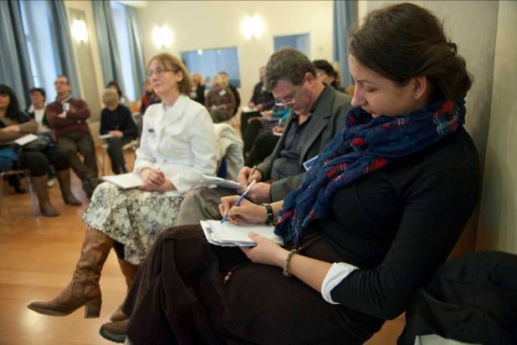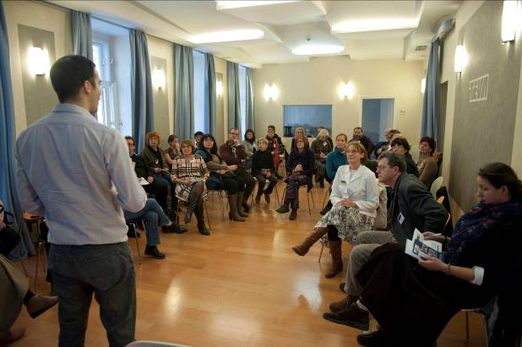
14:45. Break
15:00. Café dilemma with Haver and Uccu Foundations.
16:30. Lecture of Závada Pál Hungarian novelist
17:30. Zimirim concert (Klezmer band of Lauder Javne Jewish School)
18:00. Dinner
9. December, Sunday
9:00. Project presentations
Cili Horváth és Ágnes Fenyő, Lauder Javne School, Budapest – “Wallenberg project and Endrei Hedvig project”
Márta Ispánovity, Radnóti Miklós School, Budapest – “Intergeneration program – when students meet the interviewees”
Péter Molnár, Toldy Ferenc School, Budapest – “Haya Lea-Detinko in my teaching”
Dr. Gyöngyi Magóné Tóth, Kossuth Zsuzsa School, Kalocsa – “Methods of regional/local history research, presenting the film and project ‘There was once…’”
Zsolt Vódli, Róth Gyula School, Sopron – “Educational trips”
Zsolt Heller, KL University, Debrecen – “Ideas from the higher education system…”
11:00. Break
11:00. Closing discussion
12:30. Dinner

Background info

Since our participants have been dealing with holocaust education professionally on a regular basis, we were curious how they would describe Holocaust education in their schools. Most of them answered that Holocaust is either not taught enough, or at all in their schools.
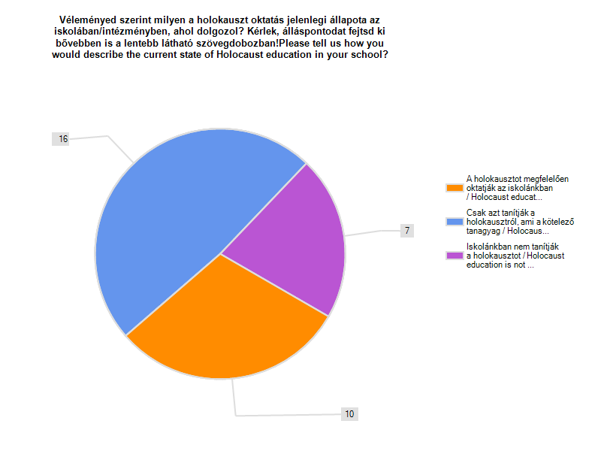
I managed to drive the attention of my collegues to deal with this issue more, but its still not enough. Technically they just let me do everything. They agree to the programs but if I would not organize something we wouldn’t even have a remambrance day….”
Éva Tóth Vásárhelyi, Budai Nagy Antal High School, Budapest

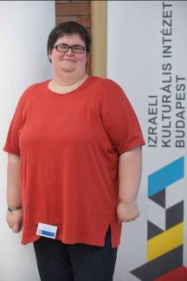
“My collegues do not think that this is an important topic. They do not confront our students – among our students we have antisemites as well. Most of the time they only make the students watch a movie and that’s it…”

Hedda Varga, Szombathely Technical High School and College, Szombathely
We also wanted to know what they think about Centropa methods after using our materials in various ways. Almost 100% of the participants confirmed that Centropa’s approach has a positive impact on their work.
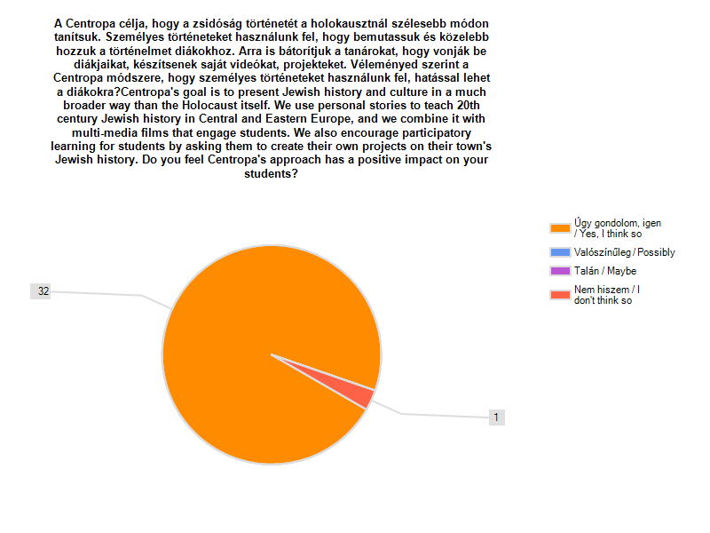
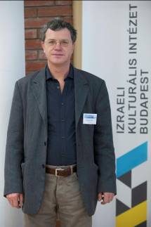
“By all means! It gives them more than the compulsory data they have to learn. To make the students work and create something has a very strong pedagocial component. It teaches them how to use their brain…”

Péter Kindler, Dobó Katalin High School, Esztergom

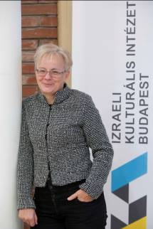
“It effects their emotions, and that’s a very good thing! The films and photos make them focused”

Nóra Baracs, Széchenyi István School, Pécs
Since this was the very first time we organized a feedback seminar, we wanted to know if this was something the participants found useful. From the answers we can see that most of the participants thought that this is something useful and necessary.
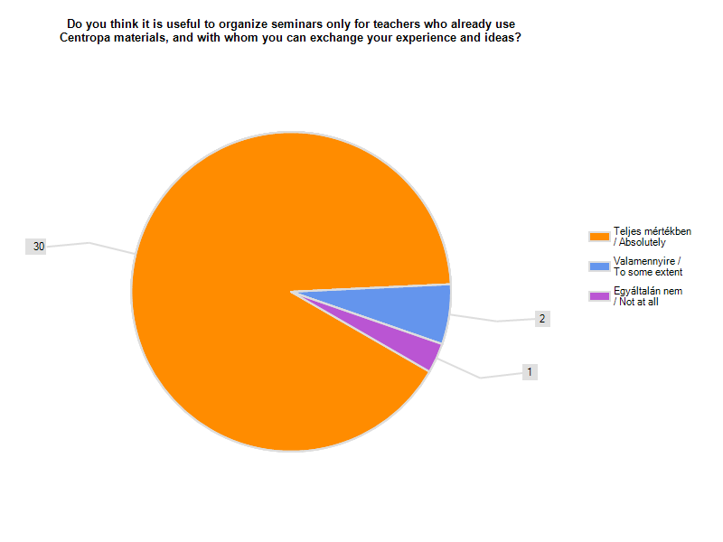
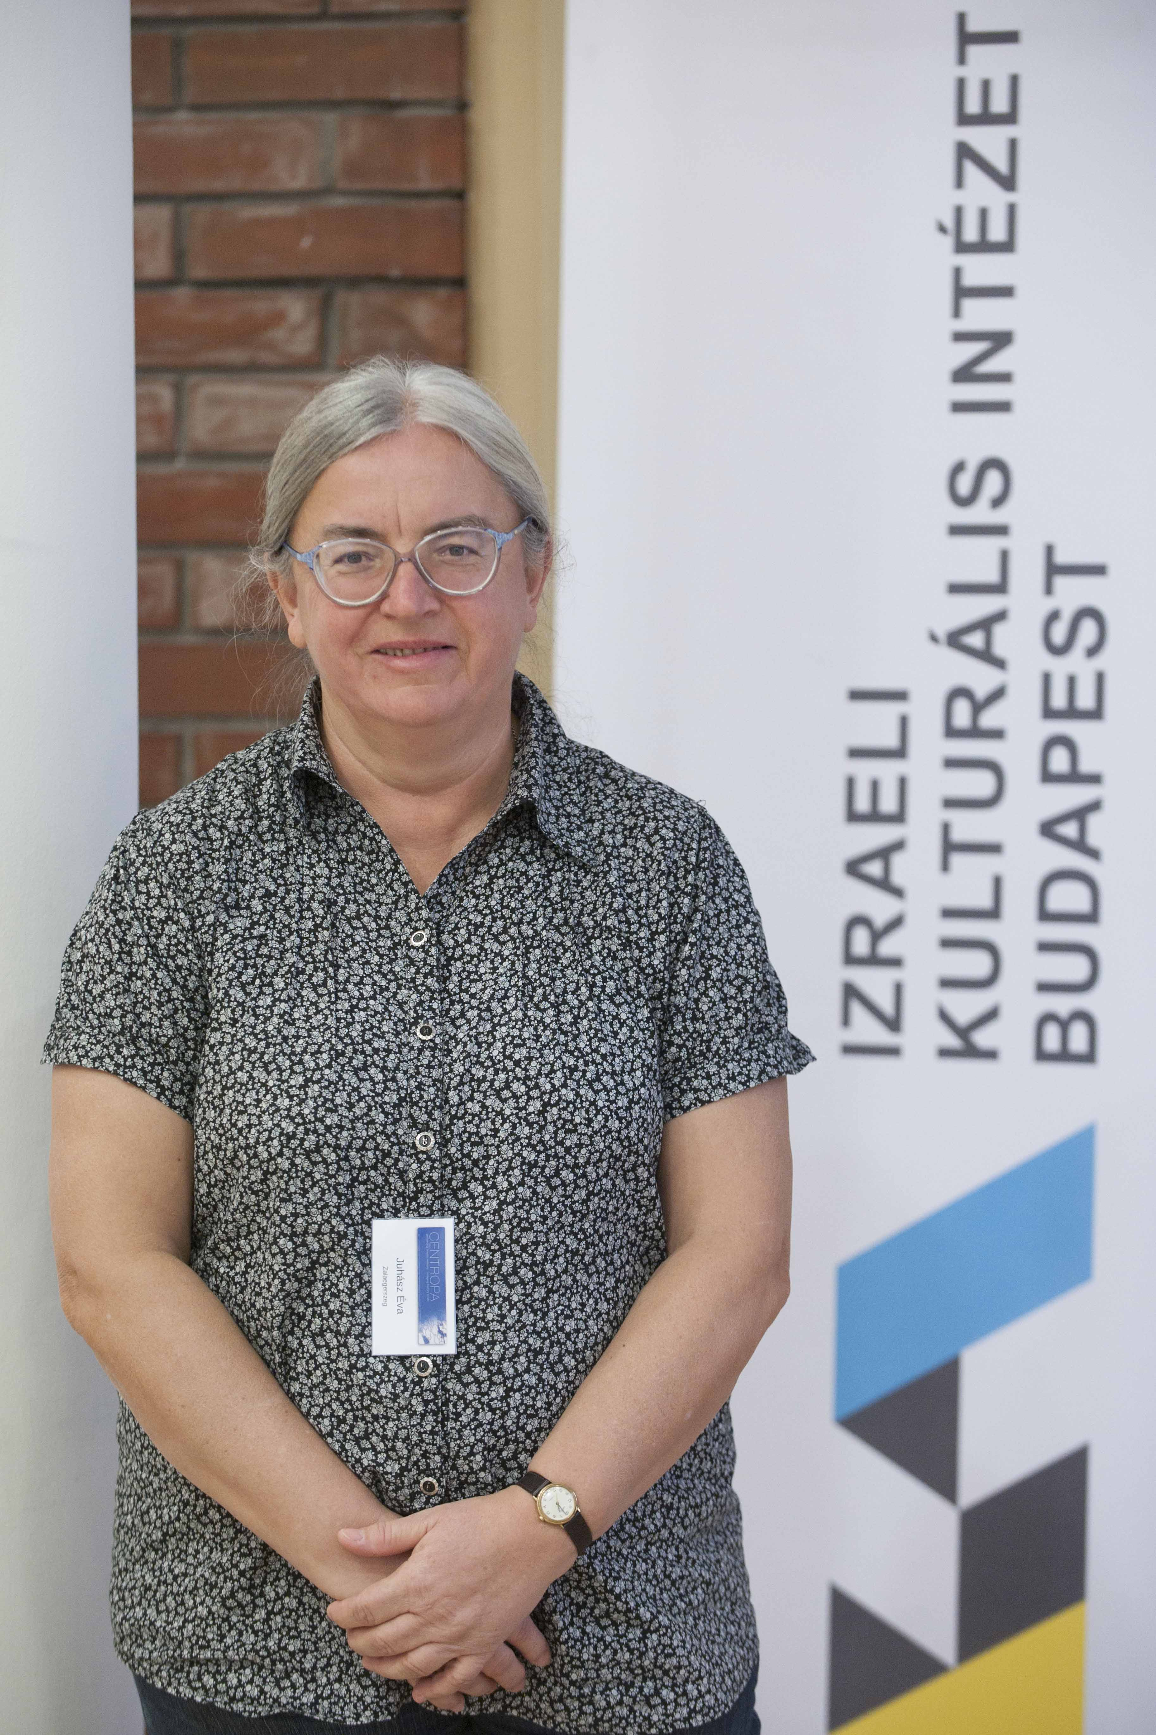
“My experience is that these Centropa meetings are getting better and better in quality and in content. A good example could be a great help of other teachers, and there is no better way to get ideas that work also in classrooms. I could image as a continuation of this that these teachers will function as multiplicators, giving their newly gained knowledge to their collegues…”

Éva Juhász, Zalaegerszeg, College of Zalaegerszeg
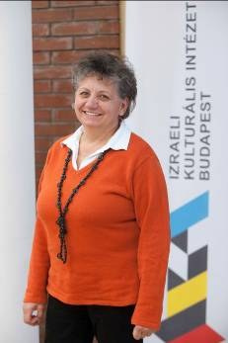
“This is definitely very important! Now we know each other and it’s so much easier to speak with teachers about the classroom experiences after we worked together… this gave me the courage to develop my own work as a teacher…”

Terka Gulyás, Mezőcsát, Mezőcsát Evangelical School
Lesson plan presentations
On Saturday we gave the floor to six of our veteran teachers to show how they used Centropa in their classrooms. We asked them to present the lesson plans and to share their experience what challenges they had to overcome during the implementation.

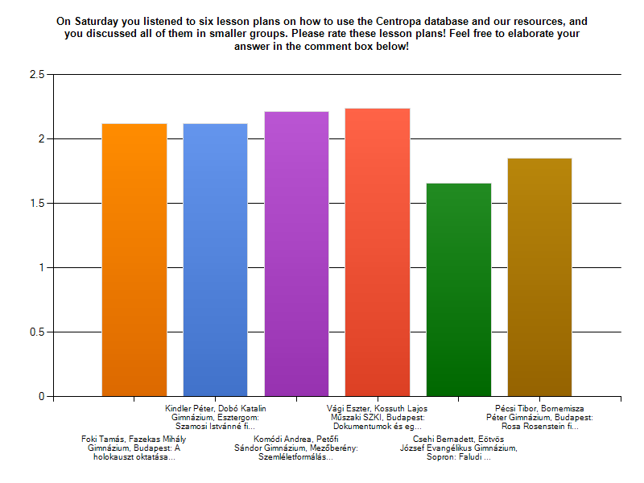
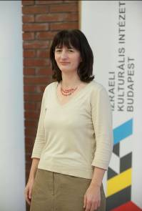
“We got a sneak preview in the colorful and valuable work these teachers are doing. It is obvious that they are engaged in longterm education, they do not only teach, they nurture their student”

Ágnes Kircz, Somogyvár Elementary School, Special and Vocational School , Kaposvár
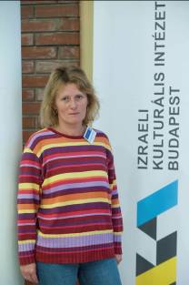
“I got many new ideas… again! It’s very good that we got to listen to lesson plans that has been already tried out and worked fine. I do not like to listen to theories and lectures anymore, these practical presentations are so much more useful to me!”
Marianna, Beregszászi, Simonyi Károly Vocational School, Pécs
Tamás Foki, Fazekas Mihály School, Budapest – “Teaching Holocaust in my school”

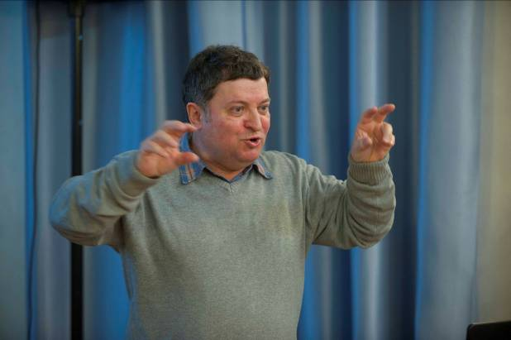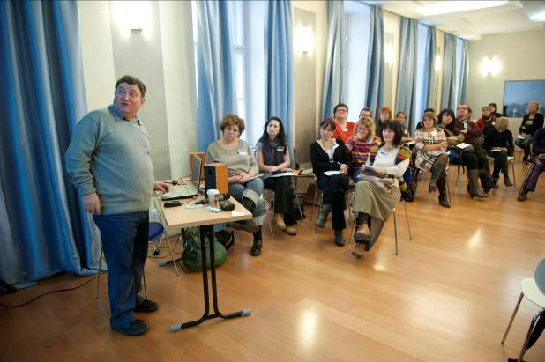

Tamás Foki is one of those teachers who attended Centropa’s very first seminars in Budapest. The Fazekas Mihály School is considered one of the best schools in Hungary. For several years the Fazekas School is leading the national ranking of high schools in the whole country.
As we know it from our seminar participants, one of the biggest challenges for our teachers is how they can fit Holocaust education in their tight time schedule. Tamás presented how they incorporated Holocaust-related education in the school curricula, and how Centropa helped them to do so. They offer themes for their teachers around the Holocaust Memorial Day for the following subjects: history, social studies, Hungarian litreture (through Miklós Radnóti).
At Fazekas school from the 8th grade every student deals with the Holocaust to some extent: they visit exhibitions, they make their own exhibitions, watch movies, every year there is a family research project where students make their own family trees, and they watch Centropa films.
See Tamás Foki’s presentation in ANNEX no. 1

Péter Kindler, Dobó Katalin School, Esztergom – “Using the story and film about Istvánné Szamosi”
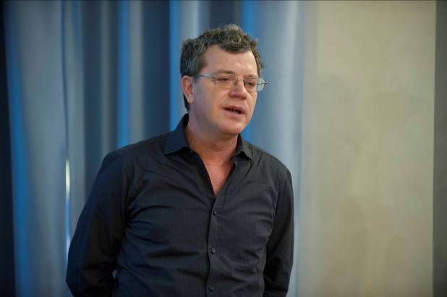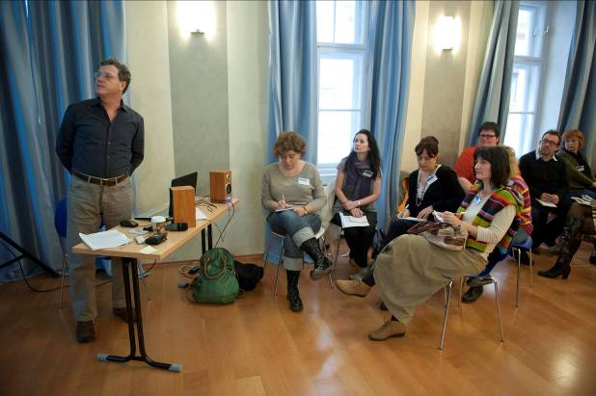
Péter Kindler teaches history and German in Esztergom, and he has been using Centropa in many different ways in his work. Mr.Kindler presented one of his lesson plans that he created during a Centropa seminar. This lesson plan showed how he uses our film about Istvánné Szamosi. Mr. Kindler also spoke about the lack of Jewish life in Esztergom today (and generally the lack of Jewish life today in Hungary outside of Budapest), and how a teacher has to be aware of this fact before going into details of 20th century Jewish history. The main point of the lesson plan is: how can we make sure that the students will understand that the history of Jews in Hungary is an important and integral part of Hungarian history at large?
See Péter Kindler’s lesson plan in ANNEX no. 2

Andrea Komódi, Petőfi Sándor School, Mezőberény – “Changing attidutes and raising interest with the help of Centropa”
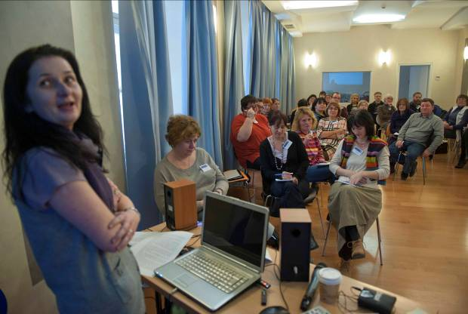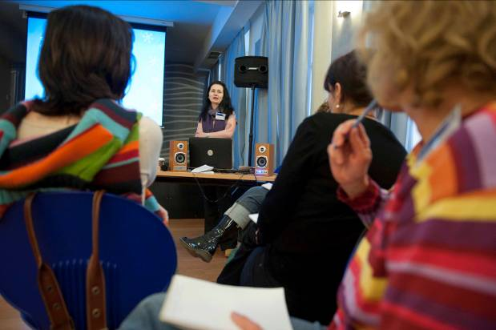
We met Andrea Komódi at for the first time in November 2011, at the seminar we organized for teachers and educators across the country. She wanted to change the way Holocaust is taught in her school. Andrea started to use Centropa films in her teaching in 2012, and as a continuation she also decided to do a video project with her students.
See the video of Andrea’s students by clicking on this link:

Eszter Vági, Kossuth Lajos SZKI, Budapest – “Using documents and simple drama methods in class”
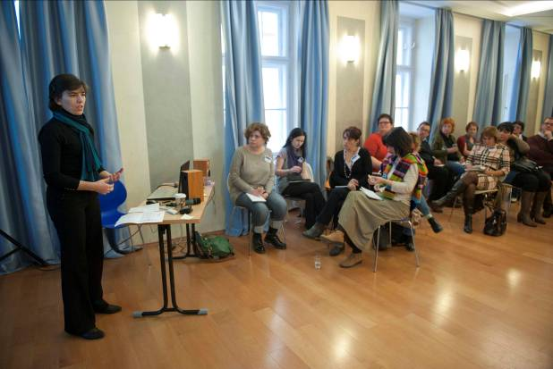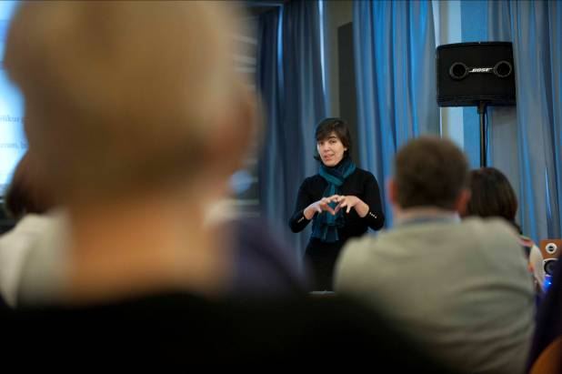
Eszter Vági is teaching theater and drama. Together with two other collegues she made a lesson plan during one of the Centropa seminars based on the Galpert and Koltai films. Eszter presented her experiences with that lesson plan; and explained how personal stories with drama techniques can be instrumental in teaching.

See Eszter’s lesson plan in ANNEX no. 3

Bernadett Csehi, Eötvös József Evangelical School, Sopron – “How I use the film about József Faludi”
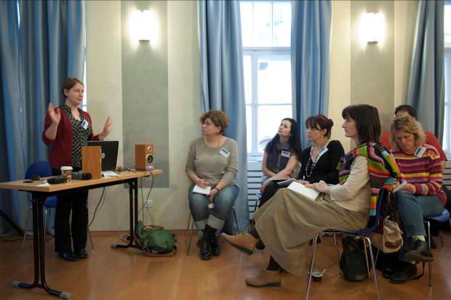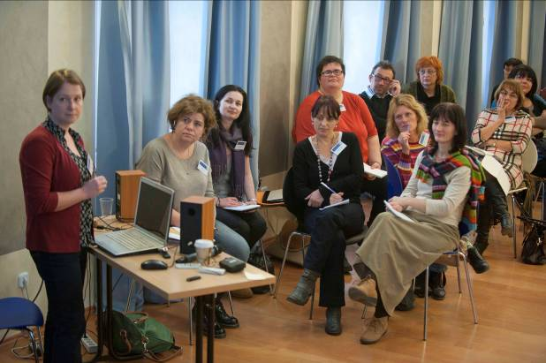
We met Bernadett for the first time in November 2011. Since then Bernadett has been using Centropa in her teaching on a regular basis. Bernadett is a literature teacher and she showed us how she involes Centropa materials in her literature classes. She used our Faludi film and explained how she combines her literature curricula with the story of József Faludi.
See Bernadett’s lesson plan, photos and other accompanig documents in ANNEX no. 4

Tibor Pécsi, Bornemisza Péter School, Budapest – “Working with the Rosa Rosenstein film”
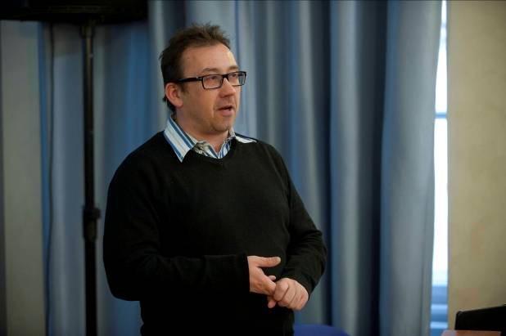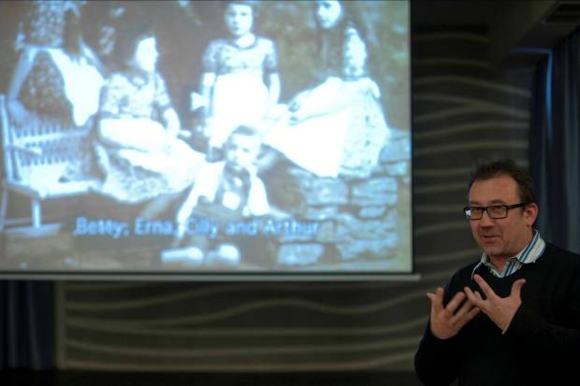
Tibor Pécsi is one of our oldest partners in Hungary. He has been using Centropa materials from the beginning. Tibor is not only a teacher but also works at the Holocaust Memorial Center in Budapest and he is the coordinator of it’s educational programs. Tibor showed us his lesson plan on our Rosenstein film, and explained how he uses Centropa as an intorduction to the whole historical period. Tibor also explained what kind of resources, documents, photos and films can be used as excellent tools.

See Tibor’s lesson plan in ANNEX no. 5

Project presentations
We always encourage teachers to think creatively, and Centropa also serves as a platform for educational ideas that work. Many of our teachers showed us how they can successully organize school events on Holocaust Memorial Day, exhibitions or videos made by their students, and other extra curricular activities. On Sunday we asked six of our veteran teachers to show what kind of projects they conducted.
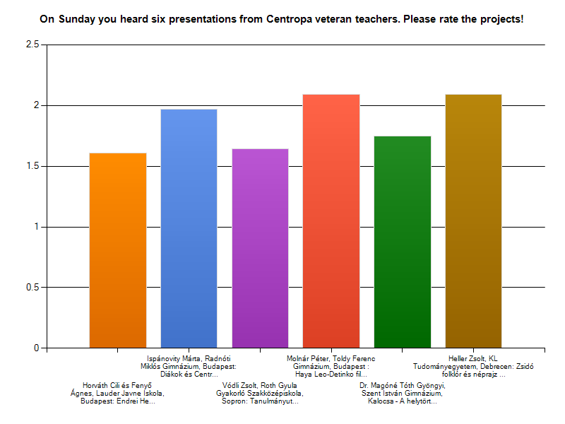
“It was very moving to see how many different ways we can find to educate about the Holocaust. Every presentation showed the personality of the teachers as well. I think all of these projects are special.”
Juhász Éva, College of Zalaegerszeg, Zalaegerszeg

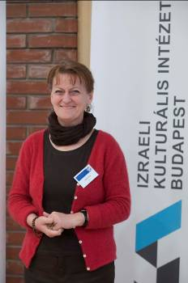
“It was such a great experience to hear all these collegues! I mostly learn from the work of other teachers, so thank you!”
Éva Hajnal, Apáczai Educational Center, Pécs
Cili Horváth és Ágnes Fenyő, Lauder Javne School, Budapest – “Wallenberg project and Endrei Hedvig project”
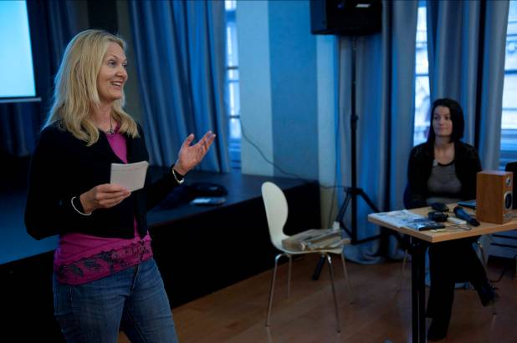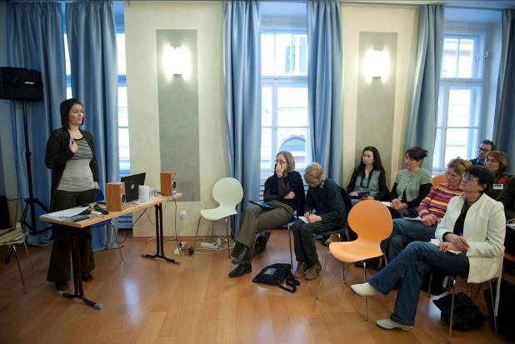
Cili Horváth and Ágnes Fenyő work as history and Hebrew teachers in the same school. Cili and Ági proved to be one of Centropa’s most innovative and creative teachers. Not only do they use Centropa materials on a regular basis, but almost every year they come up with a new project. At this seminar they presented two of them.
The Endrei Hedvig project is based on our interview with Hedvig Endrei, a survivor who wrote a cook book while being in the concentration camp of Lichtenwörth. Later Ms. Endrei became a professional cook herself, and the original cook book from the concentration camp remained. Cili organized an after class cooking workshop for her students where day learned to cook Ms. Endrei’s recepies, and nonetheless they learned history from an interesting personal perspective.
Please see the Endrei Hedvig project presentation in ANNEX no. 6
2012 was the 100th birthday of Raoul Wallenberg. Cili and Ági came up with a project idea during Centropa’s Summer Academy in 2011. They wanted to do a video on Wallenberg with their students. They ended up doing a full-year program where the students participated in a Wallenberg competition, participated in a guided tour in places connected to Wallenberg, met the niece of Wallenberg Louis von Dardel, interviewed Prof. Szabolcs Szita who wrote a book about the driver of Wallenberg, and nonetheless created a short documentary on his work during the Holocaust.
Please see the Wallenberg project presentation in ANNEX no. 7, and the video by clicking on this link:

Márta Ispánovity, Radnóti Miklós School, Budapest – “Intergeneration program – when students meet the interviewees”
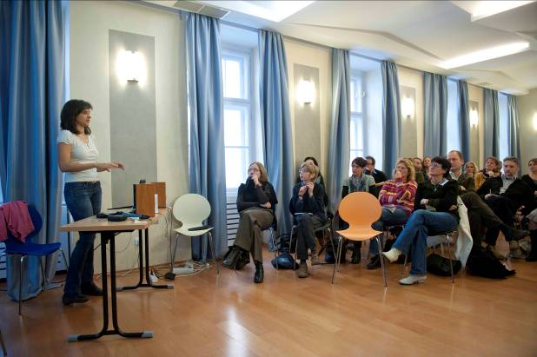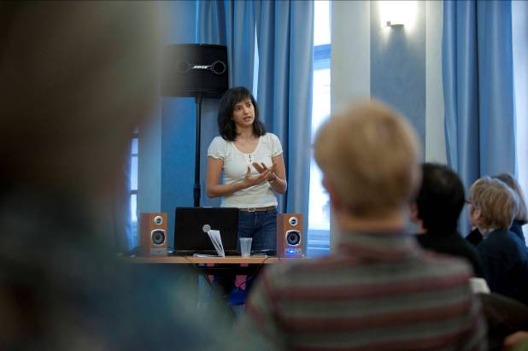
Márta teaches history in the prestigeus Radnóti School. Márta is one of our best veteran teachers. Since Márta came for the first time to a Centropa seminar she has created many lesson plans, initiated projects and extra curricular activities in her school. Márta trained her students to be tour guides for our new traveling exhibition “Photos from a family album” and she also took part in a project where her students met Centropa interviewees. She presented the latter at the seminar.
Please see her presentations in ANNEX no. 8

Péter Molnár, Toldy Ferenc School, Budapest – “Haya Lea-Detinko in my teaching”
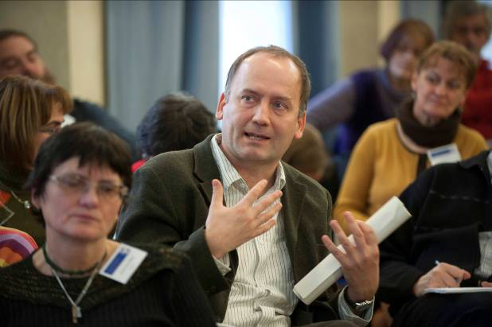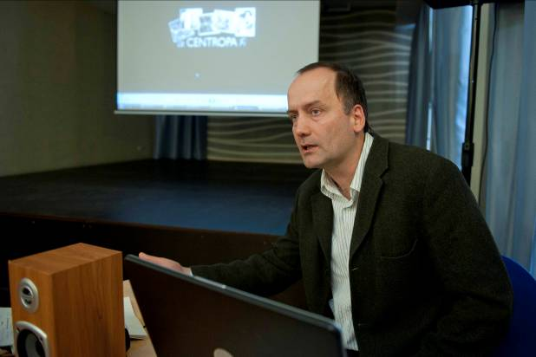
Péter is a history teacher and deputy principal at the Toldy Ferenc School in Budapest. Péter uses Centropa films on a regular basis with different age-groups and classes. He showed the way how Holocaust is taught in his school, and he also presented the lesson plan he uses the most, which is based on our film about Haya-Lea Detinko.

See the lesson plan of Péter in ANNEX no. 9

Dr. Gyöngyi Magóné Tóth, Kossuth Zsuzsa School, Kalocsa – “Methods of regional/local history research, presenting the film and project ‘There was once…’”
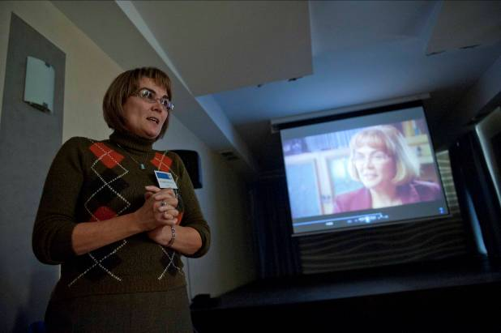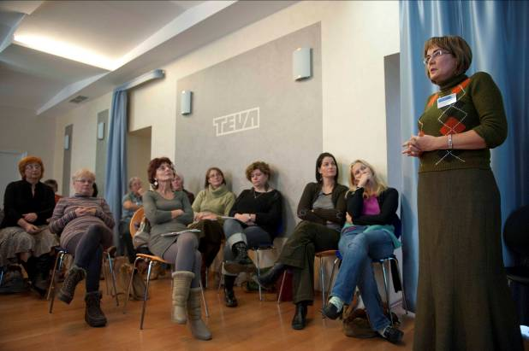
The story of Gyöngyi is well known by those who have seen Gábor Kálmán’s documentary called “There was once…”. Gyöngyi is from a small town called Kalocsa and she started to make her own research about Jewish life that once existed there. She contacted Holocaust survivors all around the world who grew up in Kalocsa, wrote her thesis on the history of the Kalocsa Jewish community and even organized a big gathering for the remaining survivors. Before becoming famous with the documentary Gyöngyi attended a Centropa seminar in Hungary, and she uses Centropa in her teaching ever since. Gyöngyi talked about her own experience both as a researcher and organizer of this big event, and as a history teacher.

Zsolt Vódli, Róth Gyula School, Sopron – “Educational trips”
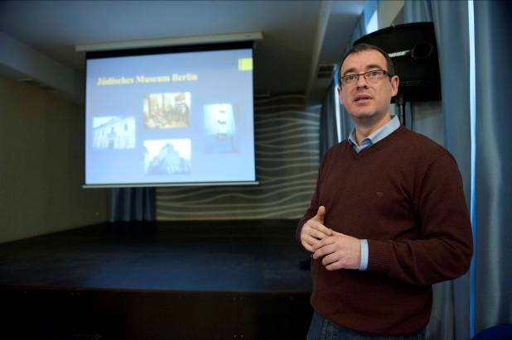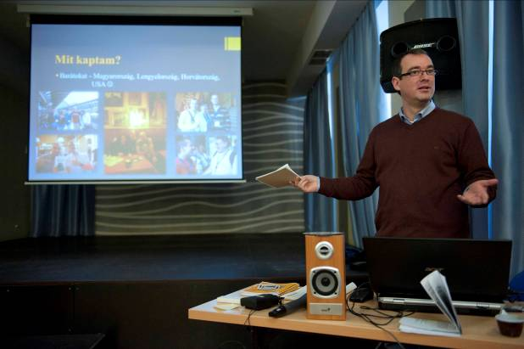
Zsolt is a history teacher in Sopron who first attended a Centropa seminar in November 2011, and he has been using our materials ever since. In 2012 we have accepted Zsolt as a participant for Centropa’s annual Summer Academy, which was held in Mannheim, Frankfurt and Berlin. Zsolt was so inspired by the program that he decided to bring his students for an educational trip to Berlin, and so he did. He explained how he planned and executed the trip, what he wanted to achieve educationally, and what he learned from the whole process.

Please see Zsolt’s educational trip guide in ANNEX no. 10.

Zsolt Heller, KL University, Debrecen – “Ideas from the higher education system…”
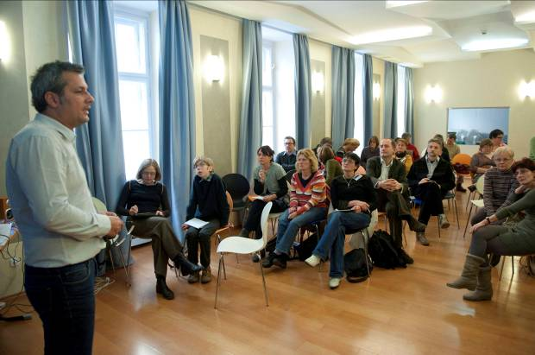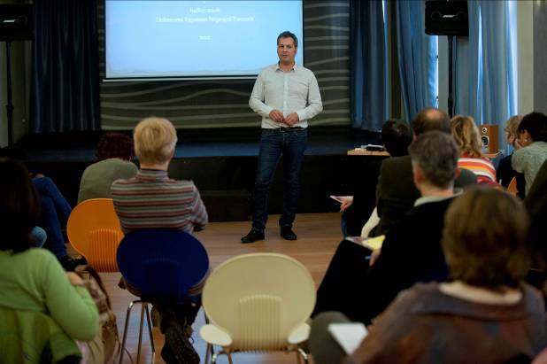
Zsolt is coming from higher education and we asked him to share his experiences about using personal stories in his own university teaching. Zsolt teaches Jewish history and folklore at the KL University in Debrecen. Although Centropa’s materials are mostly used in high schools, they are also used in other settings. Zsolt presented us how he combines personal stories with his teaching topics.

Workshop with UCCU and HAVER Foundations
Haver is a non-profit organization that stands with individuals and educational institutions to promote a diverse and inclusive society in Hungary. Haver works to combat prejudice and discrimination and to promote social cohesion through dialogue, training, education and advocacy. Uccu Foundation offers educational packages and modular educational activities to elementary and secondary school students, willing to break down discrimination and prejudical thinking about Roma community and intends to give a key to better understand cultural differences.
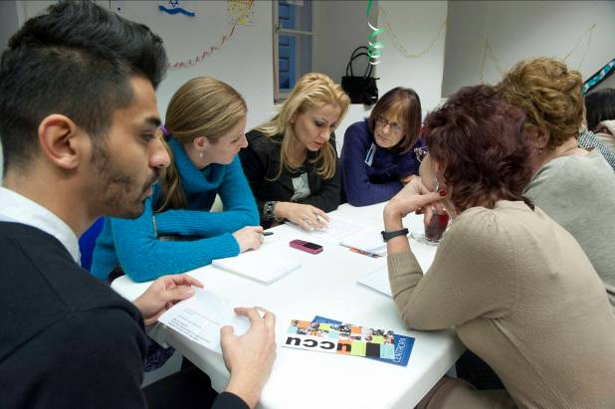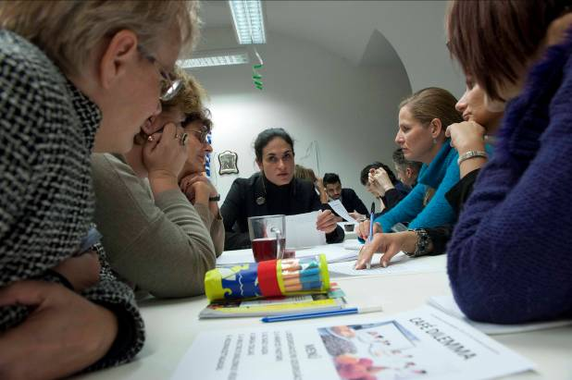
Many of our teachers face dilemmas in their schools about how to approach the problem of growing anti-semitism, intolerance, and xenophobia. Throughout their work Haver and Uccu developed unique and interesting educational methods on dealing with these issues, and gained lot of experience in facing these in real life, mostly in high schools. The volunteers of Haver and Uccu presented a program called “Café dilemma”. The teachers had discussions on dilemmas about anti-semitism, xenophobia and related issues facilitated by the volunteers of Haver and Uccu. These informal discussions brought up many pratical problems, and questions that one has to think about when dealing with the Holocaust, Jewish history, or issues related to anti-semitism, intolerance and xenophobia.
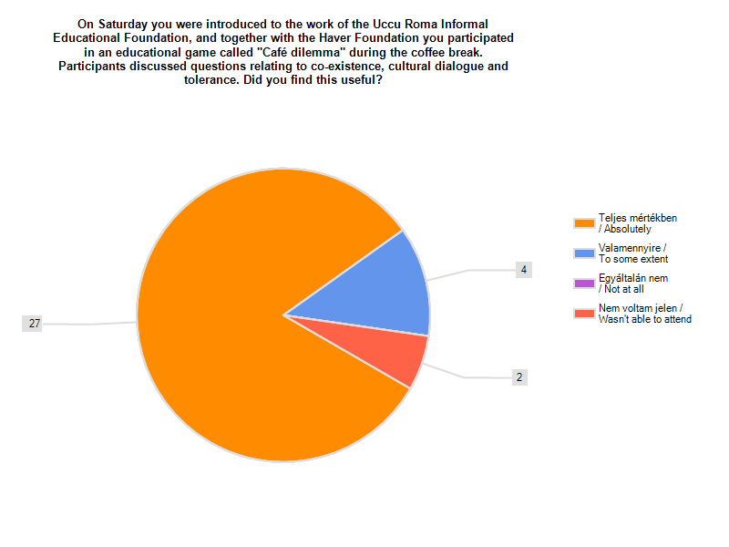

Joint Hanuka event with Café Centropa
As part of our work we organize bimonthly meetings for the survivors with whom we conducted our interviews with. We call this program Café Centropa. We wanted to give the opportunity to engage in a discussion with those eye witnesses who provided us with their stories and pictures. The participants found this to be a unique experience, as they don’t often have the chance to meet with survivors.
This time we invited members of our Café Centropa group to spend the Friday night and a dinner together with the seminar participants. When teachers meet survivors it’s a great opportunity for them to get to know the real persons behind the stories, to get inspired by them and bring this experince with them into their teaching. From time to time they can invite one of the interviewees to their schools – as we see it in Márta Ispánovity’s presentation.
On Friday we opened our program with the performance of the Gólem Theater and after that we spent a dinner together just the night before the first day of Hanukkah.
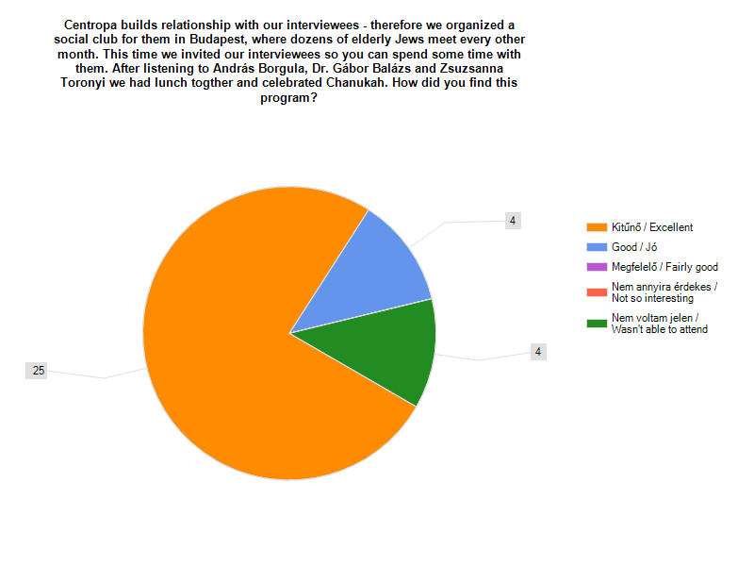

Centropa films
Since this was the first seminar we organized only for our veteran teachers we wanted to know which of our films are used the most by them. As it turned out the two most popular and used films are the Kinszki and Nussbaum films. After that our Galpert film and the intorductory film about Hungarian Jewish history are used the most.

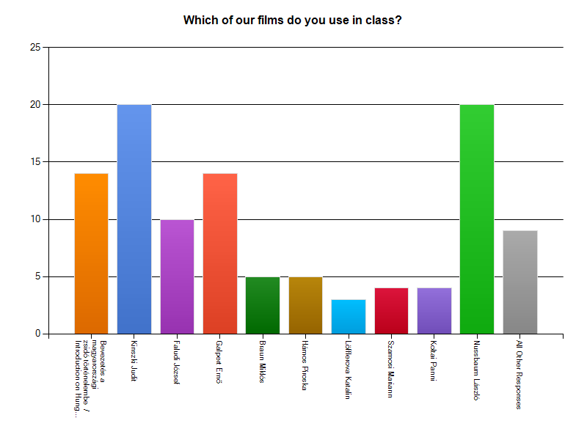
Outcomes and results

- All thirty-three participants filled out an online survey form and rated the seminar as Very Good or Excellent
- We had six lesson plan and six other project presentations that were discussed and argued by the teachers, constructive feedback was given to every presentation
- The teachers also gave us meaningful feedback about how to develop our materials, and nonetheless our educational programs
- The participants elaborated on what are the challenges and threats one has to take into consideration when using Centropa materials
- All of the participating teachers signed up to make an educational project based on the exhibition, and they also provided us with possible dates in the following school year (the first station will be Pécs and its surroundings starting from September)
- All of the participants offered to colleborate with us to conduct small workshops in their schools/towns in the future

Partners and sponsors

The Dutch Humanitair Funds provided Centropa Hungary with a grant for carrying out educational programs aiming to create an innovative and interactive way of bringing Jewish history to non-Jewish schools. In 2012 they support three seminars in Hungary.

The Bureau of Democracy, Human Rights and Labor in the US Department of State (DRL) has provided Centropa with a substantial grant for our work in Lithuania, Poland and Hungary. The DRL team helped us develop a strategy for carrying out our program, and our DRL grant is the primary means of support for our program in Hungary. The US Embassies in all three countries recruit teachers for our programs and suggest speakers.

Budget

Expenses
Items | EUR (incl. taxes) | HUF (incl. taxes) | USD (incl. taxes)
Accommodation at K+K Hotel | 1820 | 540500 | 2330
Meals for 60 people - Hanukah dinner | 980 | 291005 | 1254
Meals during seminar | 1015 | 301520 | 1300
Transportation (25 tickets) | 505 | 150000 | 647
Rental of seminar room | 337 | 100000 | 430
Welcome bags | 246 | 73000 | 315
Printing materials, nametags | 51 | 15000 | 65
Centropa staff | 337 | 100000 | 430
Photographer | 470 | 140000 | 600
Balázs Gábor, lecturer | 51 | 15000 | 65
Závada Pál, lecturer | 83 | 25000 | 108
Transportation of music band | 86 | 25400 | 110
TOTAL | 5981 | 1776425 | 7654

